

**

Faculty of Electrical Engineering and Computer Science

**Master Thesis**

EMI Filter Design and Verification using RF Simulation Tools and Measurements

**Md Moinuddin Biswas**

Matriculation Number: 5071889

A Thesis

presented to the

Bremen University of Applied Sciences

in fulfilment of the

thesis requirements for

the degree of Master of Science

in Electronics Engineering

**First Advisor: Prof. Dr. S. Peik**

**Second Advisor: Prof. Dr. Mirco Meiners**

Period: 01.06.2011 - 30.11.2021

**Abstract**

Modern technologies are depended on efficiency that includes reduction in size, cost, supply power of a system. All these efficiencies come with the obvious generation of noise. The more a device is noise-free the more it becomes efficient. All the electronic devices are produced considering the effect of electromagnetic interference. This interference is defined as the noise that travels through the electronic components like resistors, inductors, capacitors, wires, printed circuit boards, or through the overall design. This form of electromagnetic interference (EMI) has a serious impact on malfunctioning. To reduce this interference a filter is used named electromagnetic interference (EMI) filter.

Ideally, an EMI filter is a low pass filter that blocks the high frequencies as well as the noise flow while passing through the input. It will also reduce the amplitude of high-frequency signals (which are greater than the cutoff frequency). This filter is constructed with two lumped elements inductors and capacitors. There are several orders of this filter depending on the component's alignment and value.

This thesis work will deal with an EMI filter constructed with basic components. We will measure the unintended radiated electromagnetic wave from the test kit and the disturbance, also how much radiation actually produced. We will apply different valued inductors, capacitors, and chocks to measure the filter effect first and then we will synthesize the disturbances. Microwave Office software (AWR) will be used to calculate S-parameters to simulate the actual device. We are going to perform linear and nonlinear measurements to observe the filter performance as well. The simulation of this filter circuit will also be done both in frequency and time domain and at the end we will compare the performance analysis between the manufacturers’ circuit board and simulated filter.

Before starting the lab work, several filters will be designed and tested in the AWR platform to identify the least disturbance circuit. Hardware simulation will be performed after designing the proper filter schematic, and the printed circuit board accordingly.

Contents

List of Figures 5

List of Tables 6

Chapter One: Introduction 7

1.1 Literature review 7

1.2 Motivation 7

Chapter two: Theory 9

2.1 EMI in details 9

2.1.1 EMC compliance 9

2.1.2 EMI Definition 10

2.1.3 Electromagnetic Interference Classification 10

2.2 EMI Filter Design 11

2.2.1 Schematic Design 11

2.2.2 Common mode filter 12

2.2.3 Differential mode filter 13

2.2.4 Design Flow diagram 15

2.3 EMI Emissions Analysis 16

2.3.1 Conducted Emission 16

2.3.2 Radiated emissions 16

Chapter Three: Filter mode 18

3.1 Conducted Emission Analysis 18

3.1.1 Common Mode Interference 18

3.1.2 Differential Mode Interference 20

3.2 Material Selection for Hardware Design 21

3.2.1 Common mode Choke 21

3.2.2 Lumped elements 23

3.3 Noise Source Design 24

3.4 Line Impedance Stabilization Network (LISN) 25

Chapter Four: Filter Behaviour Prediction 26

4.1 Linear Simulation 26

4.1.1 S-parameter measurement 26

4.1.2 Transfer function analysis 28

4.1.3 Reflections on transmission lines 30

4.2 Nonlinear Behaviour 34

4.2.1 Harmonic Balance Techniques 35

4.2.2 Time-Domain Analysis 35

Chapter Five. Result Estimation and Discussion 46

5.1 Case Study 1: 230V 50Hz line 46

5.1.1 Linear operation 46

5.1.2 Nonlinear operation 47

5.2 Case Study 2: Experimental Examples 48

5.2.1 USB cables 48

5.2.2 Ethernet cables 50

Conclusion 53

References 54

# List of Figures

Figure 01: Classes and subclasses of Electromagnetic compatibility [2]. 10

Figure 02: Measurement relationship between EMC classes [2]. 10

Figure 03: Passive components, CMC and ceramic capacitor for building EMI filter [8]. 12

Figure 04: Standard schematic design of EMI filter [8] 12

Figure 05: Hardware design of Common mode filter 13

Figure 06: Expected input and output signal amplitude of a common mode filter [9]. 13

Figure 07: a) Common mode filter circuit diagram for software implementation, 14

b) Input, output magnitude using 100pF cap, c) Input, output magnitude using 2200pF cap 14

Figure 08: Hardware design of a differential mode filter. 15

Figure 09: Expected input and output signal amplitude of a differential mode filter [9]. 15

Figure 10: Differential mode filter circuit diagram for software implementation 15

Figure 11: Input, output magnitude using 840pF &470pF cap (left), and Input, output magnitude using 2x100nF cap. 16

Figure 12: Induced emissions in an EMI filter 18

Figure 13: Conducted Emissions path in a designed device. 20

Figure 14: Common mode part in an EMI filter 20

Figure 15: Voltage measurement of a Common mode filter 21

Figure 16: Current flow path in a Common mode filter 21

Figure 17: Common mode radiation overview. 21

Figure 18: Differential mode part in EMI filter 22

Figure 19: Voltage measurement of a Differential mode filter 22

Figure 20: Current flow path in a Differential mode filter 23

Figure 21: Differential mode radiation overview 23

Figure 22: A Common mode choke 24

Figure 23: Physical layout and circuit schematic of a common mode choke 24

Figure 24: Common mode current flow through common mode choke 24

Figure 25: Differential mode current flow through common mode choke 25

Figure 26: Impedance of a Common Mode Choke a. Measured b. Theory. 25

Figure 27: Lumped elements and current directions through them 26

Figure 28: Noise signal generator (Comb generator), physical and circuit layout. 26

Figure 29: Hardware design of a Comb generator and the input power with frequency. 27

Figure 30: Circuit diagram of LISN 27

Figure 31: Two port network diagram 28

Figure 32: Definitions of four individual S-parameters. 28

Figure 33: S-parameters measurements of CMF and DMF and comparison between measured and simulated measurements in dB. 29

Figure 34: Transfer functions of a) common mode filter, b) differential mode filter, c) common mode choke, d) transformers. 31

Figure 35: Transmission line of a two-port network 32

Figure 36: Insertion loss measurement of CM and DM filter in Hardware (measured) and Software (simulated) platform. 33

Figure 37: Power is reflecting to the source [19]. 33

Figure 38: Reflection loss of common mode filter and differential mode filter. 34

Figure 42: Common mode voltage measurement in time domain using different capacitor. 36

Figure 43: CM voltage measurement in Frequency domain using different capacitor 36

Figure 44: Differential mode voltage measurement in time and frequency domain using different capacitor 37

Figure 45: Multi tone measurement process 37

Figure 46: Multi tone a) CM filter schematic, b) DM filter schematic, c)CM input signal TD response, d) CM output signal TD response using 2x100 and 2x2200pf cap DM input signal TD response, f) DM output signal TD response of 100nF and 840,470pf cap, g) CM input signal FD response h) CM output signal FD response using 2x100 and 2x200pf cap, i) DM input signal FD response, j) DM output signal FD response of 100nF and 840,470pf cap 39

Figure 47: a) Hardware simulation for CM filter, b) Hardware simulation for DM filter. 40

Figure 48: a) Software simulation for CM filter, b) Software simulation for DM filter 41

Figure 49: Noise power for both filter both in Software and Hardware platform 42

Figure 50: Comparison between Hardware and Software simulation with different components. 42

Figure 51: Comparison between Hardware and Software simulation with different components. 43

Figure 52: Model setup for the test. 44

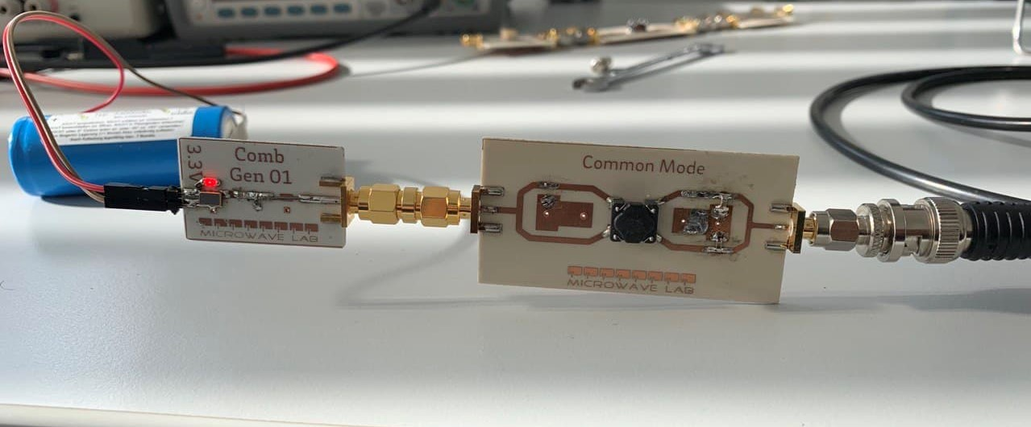 44

Figure 53: Circuit setup for the test. 44

Figure 54: a) CMF s-parameters (s11, s21) for both 2x100pF cap and 2x2200pF cap 45

b) DMF s-parameters (s11, s21) for both 2x100nF cap and 840pF & 470pF cap 45

c) Comparison between CMF & DMF insertion loss (proprsed-2x100pF & 840,470pF) 45

d) Comparison between CMF & DMF insertion loss (available-2x2200pF & 2x100nF) 45

Figure 55: Time domain response of input and output CMF & DMF for 2 set of capacitor 46

Figure 56: Frequency domain response of input and output harmonic voltage of CMF & DMF for 2 set of capacitors. 46

Figure 57: Frequency domain response of input and output harmonic power of CMF & DMF for 2 set of capacitors. 47

Figure 58: USB cable and its core layout [24]. 48

Figure 59: Circuit schematic of DM filter and CM filter with USB connection. 48

Figure 60: Common mode filter & Differential mode filter measurement for USB 1.0 cable towards the load a) CMF Power input and output in time domain (Pharm). b) CMF Input & Output harmonic power comparison. c) CMF voltage input and output in time domain (Vharm). d) CMF Input & Output harmonic voltage comparison. e) DMF Power input and output in time domain (Pharm). f) DMF Input & Output harmonic power comparison. g) DMF voltage input and output in time domain (Vharm). h) DMF Input & Output harmonic voltage comparison. 49

Figure 61: Ethernet cable and port having male and female port 50

Figure 62: Circuit schematic with common mode filter. 50

Figure 63: Common mode filter for cat5 Ethernet cable towards the load in frequency domain a) Voltage input AWR (Vharm) b) Voltage output Measured (Vharm) c) Power input AWR (Pharm) d) Power output Measured (Pharm) 51

Figure 64: Circuit schematic with differential mode filter. 51

Figure 65: Differential mode filter for cat5 Ethernet cable towards the load in frequency domain a) Voltage input AWR (Vharm) b) Voltage output Measured (Vharm) c) Power input AWR (Pharm) d) Power output Measured (Pharm) 52

# List of Tables

Table 01:Hardware measurement of CMF with 2 set of capacitors…………………………40

Table 02: Hardware measurement of DMF with 2 set of capacitors…………………………40

Table 03: Software measurement of CMF with 2 set of capacitors…………………………..41

Table 04: Software measurement of DMF with 2 set of capacitors…………………………..41

# Chapter One: Introduction

## Literature review

Electromagnetic Interference filter is an essential part of the electronic study that estimates the device efficiency. In electronic systems or devices, noise is a very common factor that cannot be avoided and is generated in many ways. Different device deals with a different type of noise according to their use or purpose. These noises can be suppressed by two very common and useful methods. One of them is filtering and another one is shielding. Although these two methods are meant to use for the different noise levels in the different frequency ranges. Filtering is a process used to remove the unwanted signal appearing while connecting to a signal generator. A filter is a device in an electronic study designed to bypass unwanted frequencies or bands of frequencies. In addition, simulation of a filter response can be done both in the frequency domain and time domain. In practice there are a number of filters are available in electronics. They are differentiated according to input and output demand. An electromagnetic interference filter is a filter that is only used to suppress the noise whatever it is conducted or radiated. The only difference is for reducing radiated noise it is marketed in a metal shield. But in the case of conducted emission, it is a very useful one as it is designed with a compensated choke. Generally, EMI filter is used in between the source and the load so that, no noise can harm the other components attached to it. There are a number of electronic circuitry where EMI filter is used like in laboratory equipment, Computer equipment, radio equipment, medical equipment, military equipment, and so on.

## Motivation

It is very important to set a goal before starting designing and implementing a device especially if it is an efficiency regulator. Before designing an EMI filter it is very important to understand the behavior of that filter and what does this filter will do, how to build this filter, how this filter will work, where this filter can be used, and how much efficient this filter will be in terms of cost and size.

What does an EMI filter do in Electronic circuitry?

EMI filter is called electromagnetic interference suppression filters that is an effective medium to protect against harmful electromagnetic interference impacts. When this filter is attached to devices or circuits it can suppress electromagnetic noise transmitted through conduction. These filters are capable to extract unwanted current conducted through wiring or cables and allow the desirable currents to flow towards the output terminal. In a certain situation, it delivers extra currents to the ground so that the rest of the connectivity remains secure from harm.

How this filter can be designed?

An EMI filter is a type of low pass filter that will allow only the low-frequency signal to pass through the filter and block the other frequencies or frequency band. That is why it is can also be designed following the design method of a low pass filter. In practice, it is generally an LC filter where instead of using the inductor, the coupled inductor is used. Coupled inductors are planned to use as they can increase or decrease the voltage or current transferring the impedance through the circuit and isolating the other devices electrically. But nowadays, it has experimented that a common mode choke is a mode flexible to use instead of the coupled inductor. A common mode choke is used as a filter itself that actually neutralizes the common mode noise from the circuitry. The capacitor plays an important role to design this filter. Two sets of capacitors are used to minimize two different noises. One set of capacitors is used in series with the choke and another set is used in shunt with the choke to control common mode noise and differential mode noise respectively. Although the purpose is different, the value of these capacitors can affect opposite noise.

How this filter will work?

Most of the electromagnetic noise is in a higher frequency range. That is why EMI filters are designed as low-pass filters that block or sift out high frequencies and let the lower frequencies pass through. There are different types of EMI filters that are designed to suppress specific noise frequencies while allowing others to flow without hampering. After completing the filtering process, unwanted noise gets diverted away from the device and is sent to the ground. Some of the EMI filters may route that unwanted currents back to the noise source or some of them may absorb that current.

Where we can place or install this filter?

Electromagnetic interferences can be generated inside the electrical device by the impendence mismatch of interconnected wiring. Interferences can also be generated by voltage variance in conductors. That is why a proper setup of this filter is needed for the device. Installation of this filter is different for the individual device it is used in. If the installation is not getting perfect then it won’t be able to perform correctly. Proper installation of components and wiring will minimize the propagation and susceptibility. Generally, a filter should not be installed very close to the source and the load or too long to the power line. When the installation is closed then the filter will not be able to complete the filtering process properly and the signal will escape without suppression of the filter and directly coupled to the other end with interference. It is better if the connection cable is twisted pair because twisted pair cable can eliminate high-frequency interference signals.

EMI filter remarks a vital role in the recent electronic and electrical signal process. This thesis will emphasize the overall performance of an EMI filter having both linear and nonlinear properties and response both in frequency and time domain.

# Chapter two: Theory

## EMI in details

### EMC compliance

In a system, electronic or electrical devices emit electromagnetic interference known as radiated and conducted emissions. These emissions and this interference affect the overall performance of the system and can cause undesirable effects such as physical damage to the equipment. Electromagnetic compatibility (EMC) is the measurement of the ability of a device to function satisfactorily in an electromagnetic environment without causing undue electromagnetic interference [1]. The main purpose of EMC is to limit the generation of unintended signals and the propagation and reception of electromagnetic energy as an output signal.  
  
EMC can be divided into two main categories. Each of these categories can also be divided into two categories. EMC can be defined by understanding and identifying any or all of these issues.

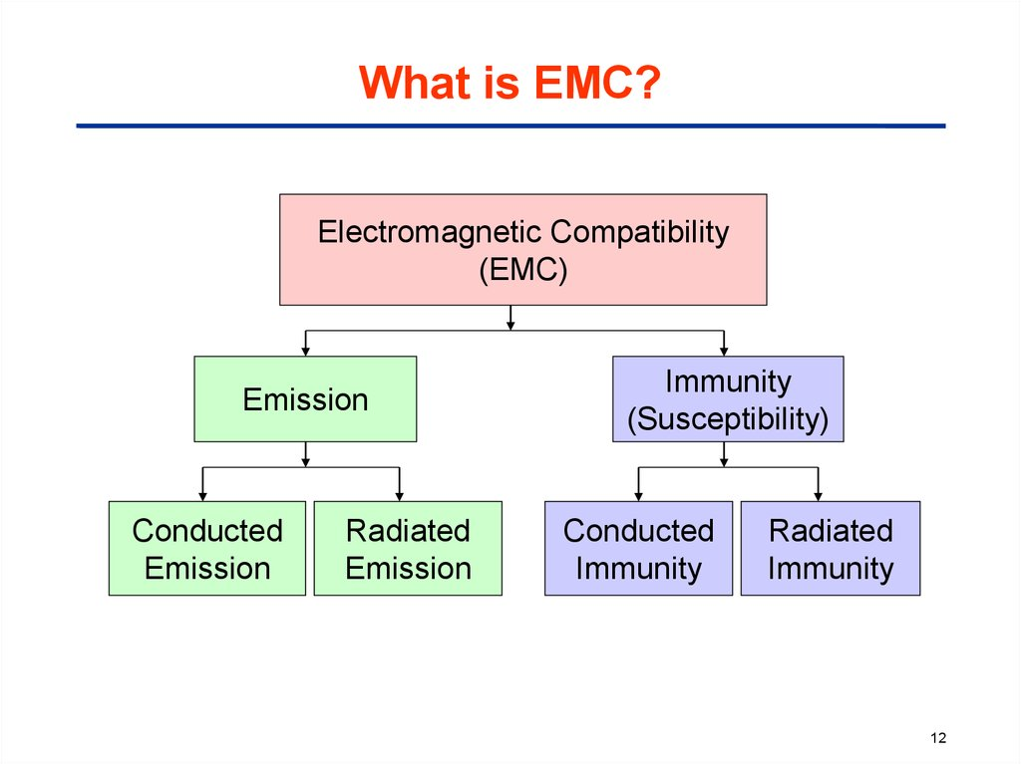

Figure 01: Classes and subclasses of Electromagnetic compatibility [2].

Emission is the intentional or unintentional generation of electromagnetic energy by a source that is released into the environment. EMC considers these unwanted emissions and countermeasures that mostly reduce unwanted emissions. Electrical equipment that is disturbed or fails due to unwanted emissions is referred to as susceptibility or radio frequency interference (RFI) [3]. In the case of immunity, a system or device functions correctly when a radio frequency is present. Hardening of equipment is also referred to as susceptibility or immunity.   
  
A third problem, which is a very common content of EMC, is the coupling through which the radiated interference reaches the victim.

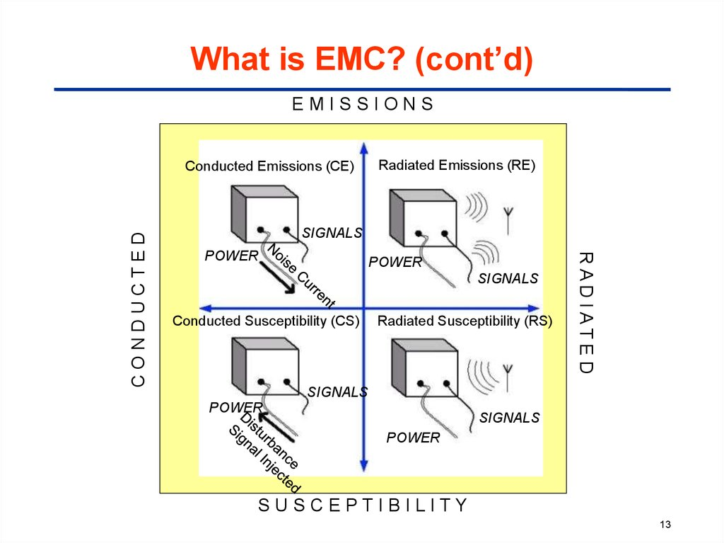

Figure 02: Measurement relationship between EMC classes [2].

### EMI Definition

Electromagnetic interference is defined as an electromagnetic disturbance that can affect the performance of a device, equipment, system, or subsystem and cause malfunction of the equipment that generates electromagnetic induction or emits electromagnetic radiation.

When an electric field comes into contact with a magnetic field, electromagnetic (EM) waves are generated. EM Waves can travel at a very high speed like the speed of light in a vacuum and can propagate through anything, whether it is air, solid materials, or waves [4]. They occur when an electronic device is not shielded from an electromagnetic field. Any device that has electronic circuitry and is connected to the power supply can respond to EMI.   
  
EMI is the combination of two or more waves that can result in larger, smaller, or equal measured waves than the original wave [5]. Therefore, the resulting wave may possibly be different from the original waves and may also be unsuitable for its purpose.

### Electromagnetic Interference Classification

1. EMI can be generated by a variety of sources. EMI types are classified according to how they are generated:

Man-made EMI: This type of EMI is generally generated by electronic circuits or electrical equipment [6]. Examples include power lines, car ignitions, fluorescent lights and so on.  
  
Naturally caused EMI: This type of EMI can be generated by many sources, such as extraterrestrial sources like radiation from the sun and galactic sources like radio stars, galaxies and other cosmic sources, atmospheric charges or discharges like lightning.

ii. The second method of classifying EMI types is based on their duration:

Continuous Interference: if a circuit is connected to a source and emits a continuous signal, then this type of EMI generally emanates from that source. However, continuous background noise can originate in a variety of ways, either man-made or natural.

Impulse noise: These include lightning, ESD, and switching systems, all of which contribute to impulse noise, a form of EMI. This type of EMI can be man-made or natural.  
  
iii. EMI can also be classified according to its bandwidth.

Narrowband: This EMI is likely to involve a single carrier source. The signal produced by intermodulation and other forms of distortion is also a form of narrowband EMI [7]. It can occur at various points in the spectrum. It may be responsible for interference to another user.  
  
Broadband: Broadband EMI can be generated by various sources. Man-made broadband interference can come from sources that continuously generate sparks. Naturally occurring broadband noise can be generated by the sun. When the sun appears behind the satellite, the noise can obscure the desired satellite signal.

## EMI Filter Design

In this paper, EMI filter is designed considering the basic components a low pass (LC) filter need. Instead of inductors I have used a current compensate choke (coupled inductor) and ceramic capacitors.

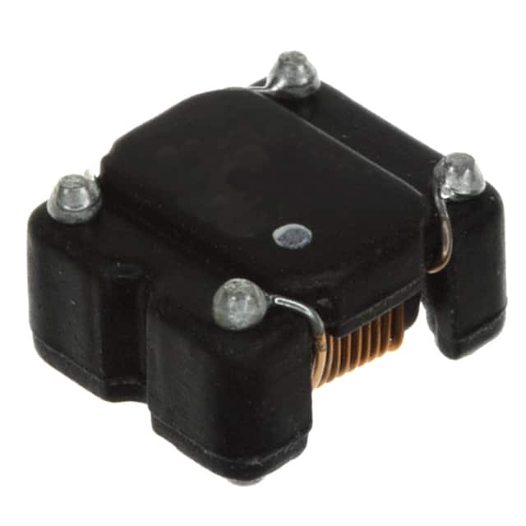 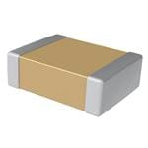

Figure 03: Passive components, CMC and ceramic capacitor for building EMI filter [8].

### Schematic Design

Noise that can be generated in a device are two in types, one is common mode noise and the other one is differential mode noise. These noises can be attenuated using an EMI filter. Various components are used in this filter, including ceramic capacitors and current compensated common mode chokes. Common mode noise is generated due to the current flow from both line and neutral to ground [7]. Since the common mode choke has a high impedance, capacitors are needed to dissipate the common mode noise. The common mode choke can also generate leakage inductance. On the other hand, differential noise is generated by the rapid change of current on the lines between line and neutral and the induced leakage inductance.

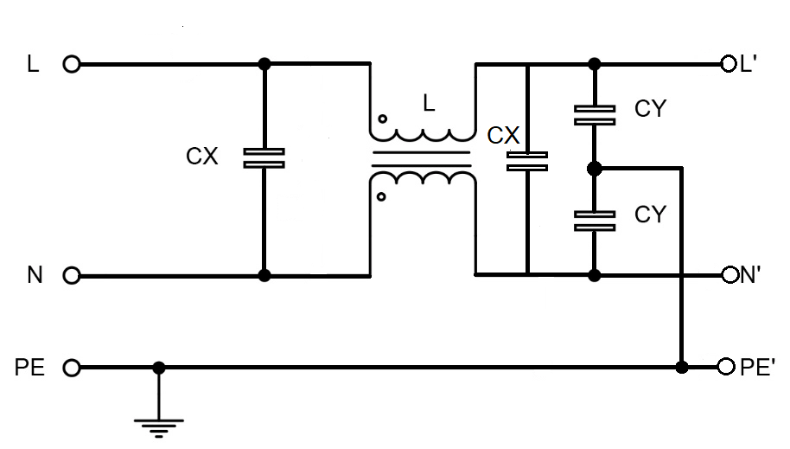

Figure 04: Standard schematic design of EMI filter [8]

Considering the mode noise, the EMI filter is constructed with two different filters named after the generated noise. One is the common mode filter, which is designed to reduce only the common mode noise, and the differential mode filter, which is designed to reduce the differential mode noise. Since we are using passive elements in each of the filters, there may be very little variation in the common-mode noise or differential-mode noise and may be fluctuated due to the capacitors which are planned to use for minimising opposite mode noise.

### Common mode filter

In an EMI filter, a common mode filter is meant by the passive element common mode choke. It is used because the common mode current generates a magnetic flux in the opposite direction and produces almost zero inductance. In the following, a common mode filter is shown that is designed for our purpose.

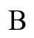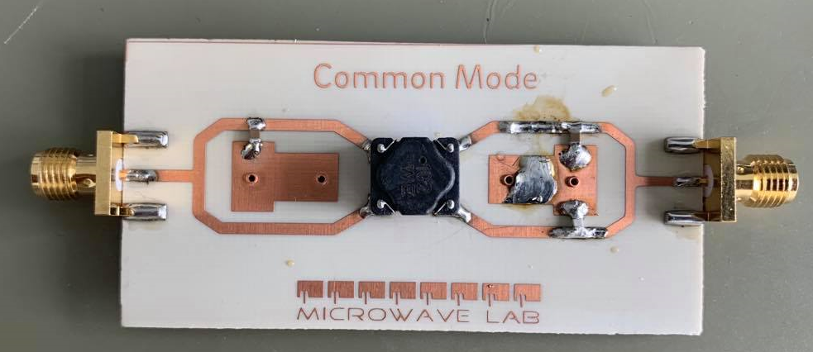

Figure 05: Hardware design of Common mode filter

In the Figure 05, input signal is provided where noise is also passing with the main signal through the port A. The main signal should have filtered the common mode noise generated in the input and at the output the noise will be filtered. The amplitude will be lower than the main signal as with the current as the noise current will pass through the capacitor used as Y capacitor. The input and the output signal should have the following pattern.

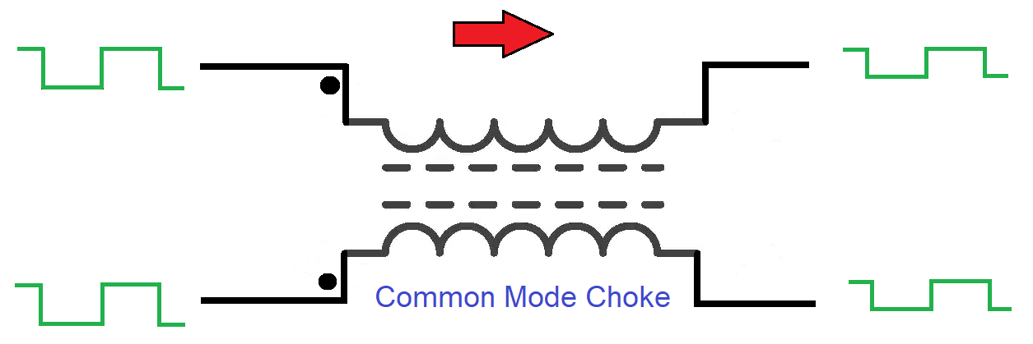

Figure 06: Expected input and output signal amplitude of a common mode filter [9].

In our experiment we have got the input output signal in the common mode but the output signal is not as expected due to the transient properties or harmonic imbalance and loss due to the component I have used.

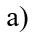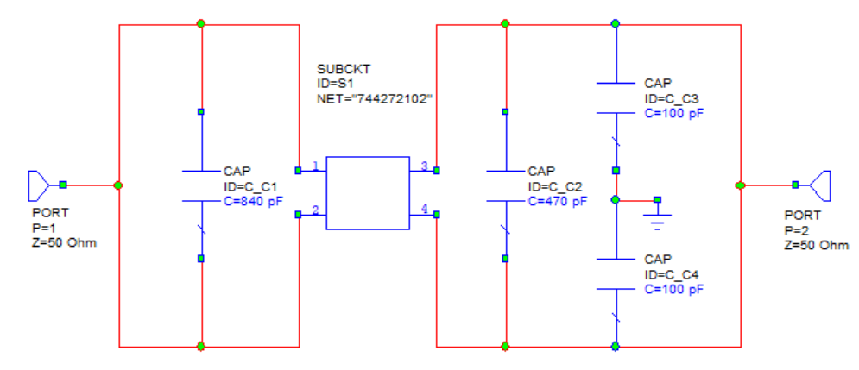

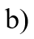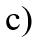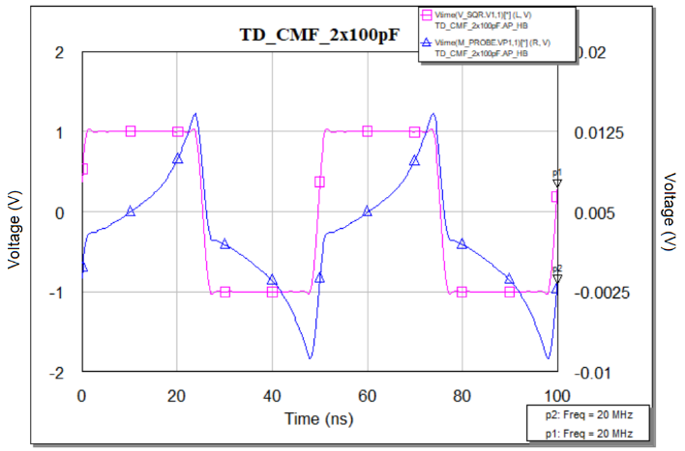 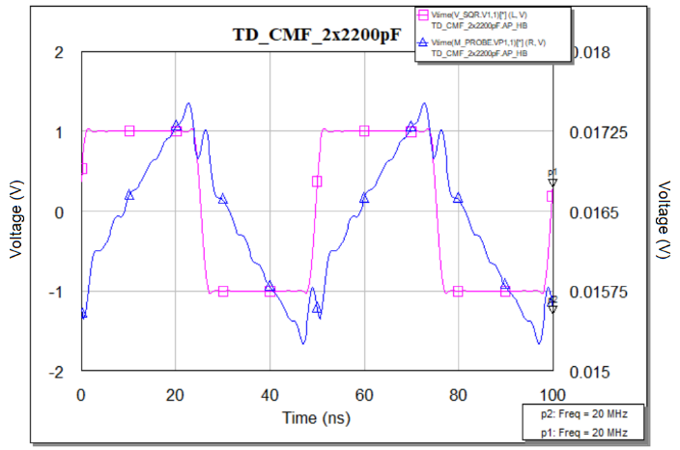

Figure 07: a) Common mode filter circuit diagram for software implementation,

b) Input, output magnitude using 100pF cap, c) Input, output magnitude using 2200pF cap

Discussion: Figure 07a) shows the schematic design of a common mode filter where 100pF two capacitors have been used to reduce the common mode noise and the noise current will be transferred to ground. In Figure 07b) time domain response of the common mode filter where the input signal is square wave having magnitude is 1 volt and in the output signal due to the transient property, the shape will be changed. The magnitude decreases as expectedly but the phase remains unchanged (very little time jitter). If we use Y capacitors 2200pF instead of 100pF the output graph totally change and the magnitude will also decrease.

### Differential mode filter

In an EMI filter, differential noise is a major issue in case of generated conducted emissions. Differential mode noise is generated from the source in an ordinary way that is why it is called general noise. There is another source from where differential mode noise can be generated. The leakage inductance induced due to magnetic flux of the common mode choke is the secondary differential mode noise. That is why there are two X capacitors are used at the two terminals of the common mode choke. One will reduce the differential mode noise generated due to general current flow from the source and another one will reduce the induced current due to leakage inductance. In the following, we can understand the hardware design.

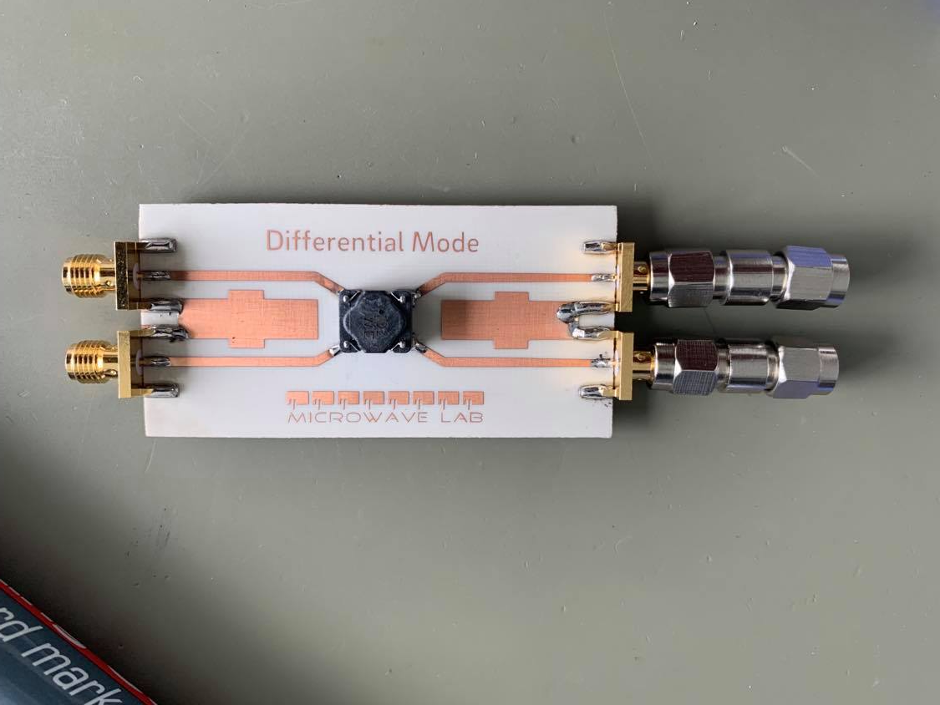 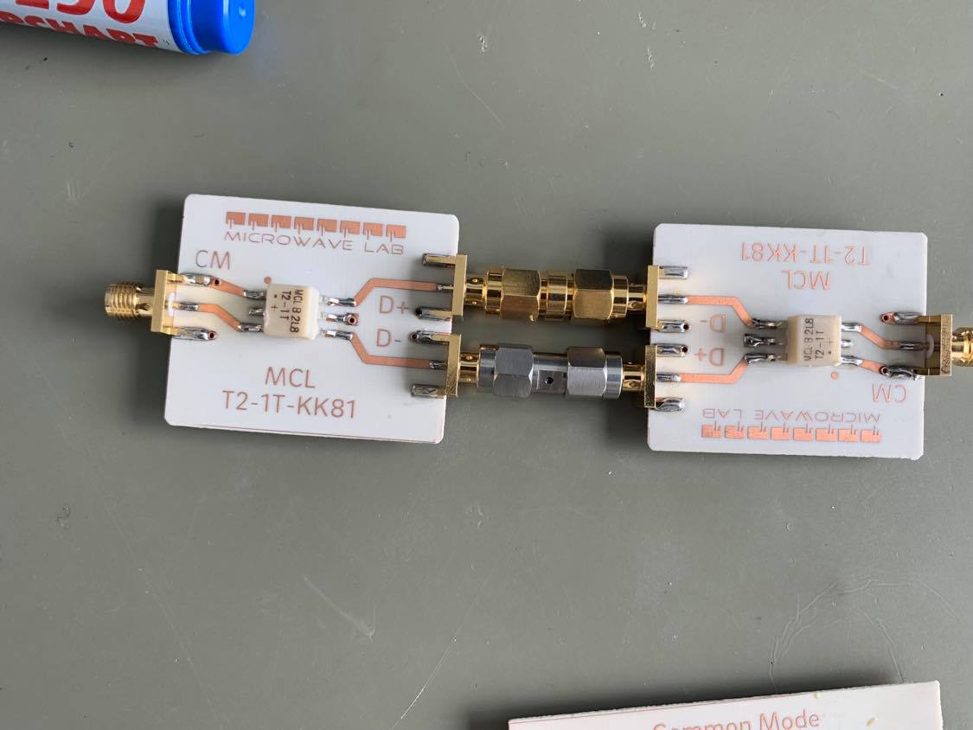

Figure 08: Hardware design of a differential mode filter.

Figure 08 shows a differential mode filter that will have two X capacitors. Two transformers will be installed in the both in and out terminal of the differential mode filter to observe the noise and identify the magnitude as the generaded value supposed to be very small. The input and output signal in a differential mode filter should be like figure 09.

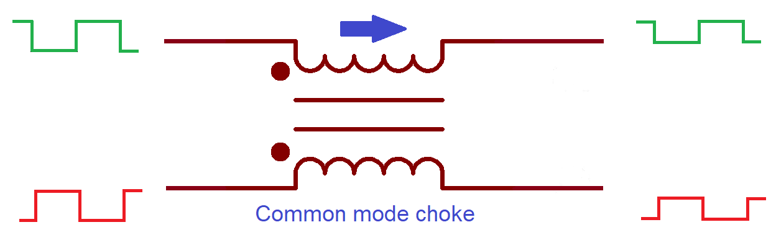

Figure 09: Expected input and output signal amplitude of a differential mode filter [9].

The software implementation provides a different result for the square wave in the output side. Since we can get almost close results.

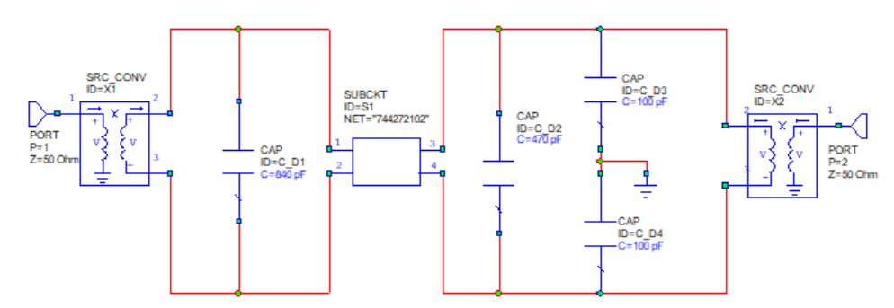

Figure 10: Differential mode filter circuit diagram for software implementation

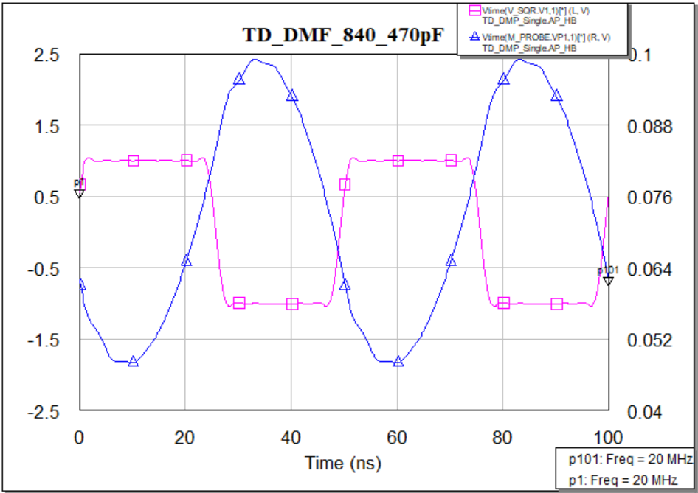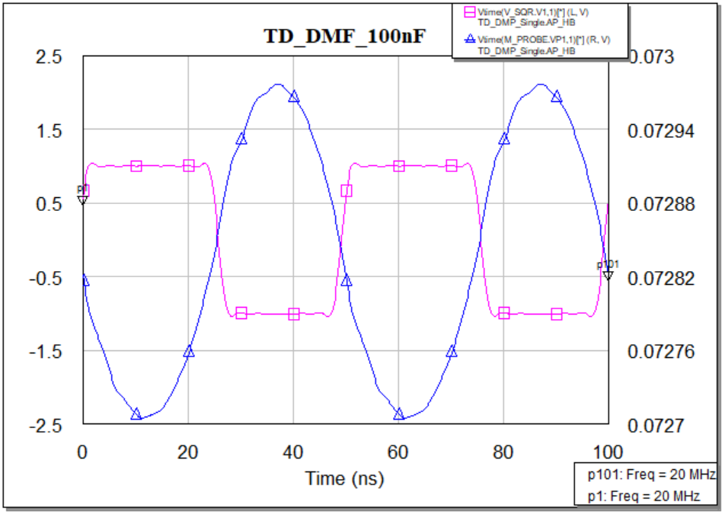

Figure 11: Input, output magnitude using 840pF &470pF cap (left), and Input, output magnitude using 2x100nF cap.

Discussion: Figure 10 shows the schematics design of a differential mode filter where 2 transformers are also used as in the hardware design we have tested. These two transformers will be used to step up and down in the input and output voltage. We have two almost the same graphs of differential mode filer of input and output time domain response. In the figure 11, we can observe two output responses having difference in the magnitude but the phases are same. As we decrease the value of X capacitors the magnitude increases and the shape come close to the input signal*.*

### Design Flow diagram

The design flow diagram will explain the total overview of this thesis work. At the very first we have designed the standard structure of an EMI filter what we have tested a number of times that is the inductance value of the common mode choke. As well as we have also checked the frequency range, rated voltage, and rated current. The ceramic capacitor also has been changed a number of times for the suitable response both in the time and frequency domain. From the footprint we designed PCB and the work stated. All the simulations have been done and a number of techniques have been followed to observe and record the output response of the filter. In this whole project, the main focus was only on the filter response and its functionality. As the whole EMI filter was partitioned into two different filters, the measurement process was a bit lengthy and complex. To observe the input and output results and compare them for a range of frequencies and doing the whole process for the different setup was a bit scattered for documentation. That is why the flow diagram is helpful to understand the whole project work.

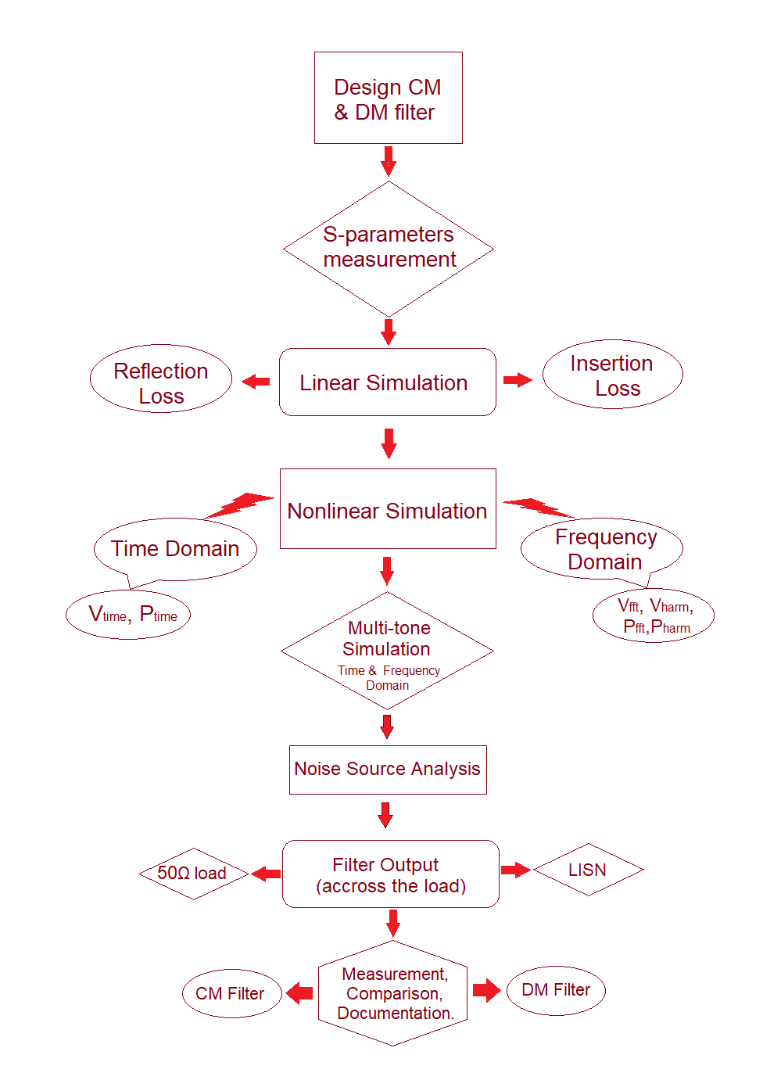

## EMI Emissions Analysis

When an electromagnetic energy is generated by any source whether accidentally or deliberately and is released into the environment then the existence of Emission is establish. EMC studies allows to identify these unwanted emissions and the countermeasures which may be taken in count to reduce this unwanted emissions.

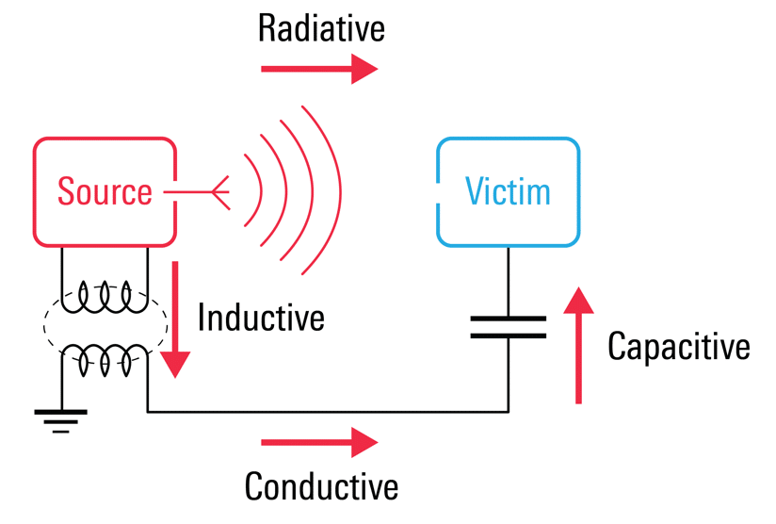

Figure 12: Induced emissions in an EMI filter

### Conducted Emission

Conducted Emission is the mechanism where electromagnetic energy is created in an electronic device or sub-circuit and is transferred to another device or sub-circuit via cabling, PCB traces, power or ground planes, or capacitance [10]. This emission is capable to travels through a conductive path. This emission can be continuous or discontinuous. Continuous emissions are emitted at a given frequency but discontinuous emissions are non-constant and occur sporadically.

The frequency range for the conducted emissions standards is 150 kHz to 30 MHz. But this range may go higher or lower for a specific standards. There are some standards that use different frequency ranges. Different value of impedances is also a concern for the manufacturers.

The three most common standards CISPR 11, CISPR 14–1, and CISPR 22 and corresponding EN standards specify measurement in this frequency range. CISPR 13 (for broadcast receivers) and CISPR 15 (for lighting equipment) also require a similar range. CISPR 15 calls for measurement from 9 kHz to 30 MHz [10]. Conducted EMI at below 9 kHz frequencies is usually categorized as low frequency while that between 9 kHz to 30 MHz is categorized as high frequency.

### Radiated emissions

Electromagnetic energy that is generated from an electronic device intentionally or unintentionally is called radiated Emissions. Radiated emissions spread through the air from the device’s chassis. It can also radiate from interconnected cables. HDMI ports are a good example that radiate emissions. Typical magnetic field loop antennas such as the Van Veen Loop antenna measures the magnetic field emissions of a product in three-axis [11].

Circuits are filled with time-varying signals that propagate electromagnetic radiation into space. In that sense, every conductor that carries electrical currents behaves like an antenna that source energy into the surrounding and simultaneously transmits and receives radiated EMI.

The standard frequency range given by CISPR22 and EN55022 standards was 30 MHz–1 GHz intended for computers and communications-related equipment. The emission levels for Class B components are 30 dBμV/m in the frequency range 30–200 MHz but emission levels increase up to 37 dBμV/m as the frequency increases up to 1 GHz from 200 MHz.

# Chapter Three: Filter mode

## Conducted Emission Analysis

Conducted emission is the electromagnetic interference (EMI), or noise that originates from frequencies of an electronic or electrical device. These interference are then spread out along with interconnecting cables. Cables may be signal ports, wired ports such as telecommunication ports, or power conductors.

Conducted emissions are typically divided into two types: Common mode and Differential mode.

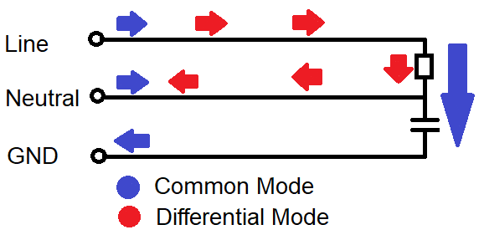

Figure 13: Conducted Emissions path in a designed device.

### Common Mode Interference

Common-mode noise is the line to ground noise generated on both sides of the AC input and in phase with its ground. It is an asymmetrical noise. The current of the common mode noise flows in the same direction through the power line and the neutral and returns through the ground conductor. The common-mode noise can be suppressed by the common-mode choke and the Y capacitors used in the EMI filter.

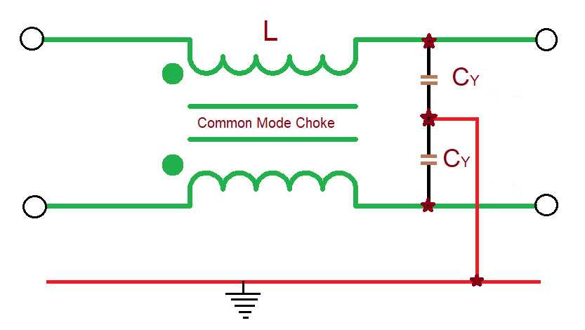

Figure 14: Common mode part in an EMI filter

#### Common mode voltage

Common mode voltage is an asymmetrical and unbalanced voltage. It is defined as the voltage between the conductor line and the ground, or as the mean of the phasor voltages appearing between each conductor and a specified reference, usually earth or frame. If V1 and V2 are voltages on phase and neutral respectively, then the following expression gives the common mode voltage.

The voltages induced by external electric fields are generally common mode voltage ‘VCM’ given by:

VCM = (V1+V2) / 2 (1)

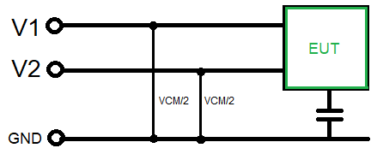

Figure 15: Voltage measurement of a Common mode filter

#### Common mode current

Common mode currents are those currents that flow in the same direction on line and neutral and return via ground. If I1 and I2 are currents on line and neutral, then the common mode current ICM is given by the vector sum of those two currents [10].

ICM = I1 + I2  (2)

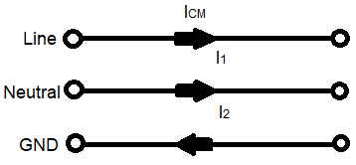

Figure 16: Current flow path in a Common mode filter

#### Radiation due to Common mode noise

When in a system, the electric field intensity radiates due to the common-mode noise and current flow from transmitter to receiver having a specific distance then that field can be expressed by the equation (3). Cable length L is an important factor to solve the equation. The distance from the observation point to the channel is denoted by r. So it is seen that the electric field id depended on the cable length proportionally.

ECM ∝ (3)

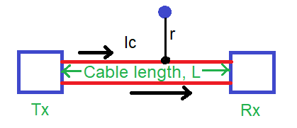

Figure 17: Common mode radiation overview.

### Differential Mode Interference

Differential mode interference is referred as the signal that is generated in between line and neutral and because of the leakage inductance of the common mode choke which is generated due to short of two-port of the choke.

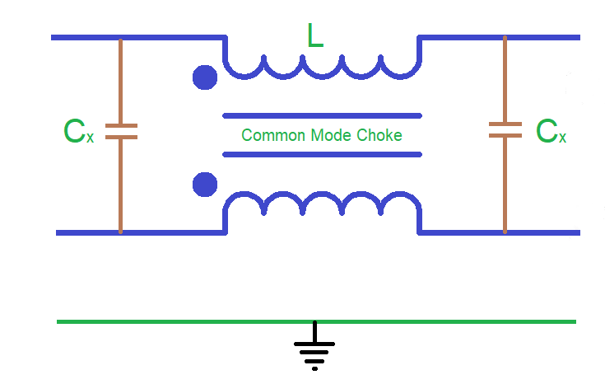

Figure 18: Differential mode part in EMI filter

#### Differential mode voltage

Differential mode is also known as normal mode or symmetrical mode. It has a balanced voltage that is generated in between the line and neutral wires [10]. Equation (4) shows the differential mode voltage VDM. It is the difference of the voltages of line and neutral is given by:

VDM = V1 – V2  (4)

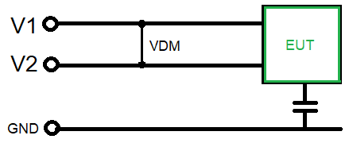

Figure 19: Voltage measurement of a Differential mode filter

#### Differential mode current

Differential mode current is equal to the half of the vector difference of current that flows through line to neutral in cross-section area. In simpler terms, differential mode currents flow in opposite directions. The differential mode current is given by:

IDM = (I1 – I2) / 2 (5)

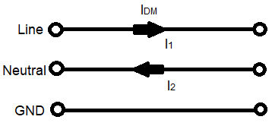

Figure 20: Current flow path in a Differential mode filter

#### Radiation due to differential mode noise

The electric field intensity of the differential mode noise can be represented by equation (6), where the noise current flowing in the differential mode is Id. The distance to the observation point and the noise frequency are 'r' and 'f', respectively. Differential mode noise generates a current loop, which is generally the noise current. We have considered this loop range S. From equation 6, we can see that the intensity of the electric field increases as the area of the loop increases, and vice versa, while the other elements remain constant.

EDM ∝ (6)

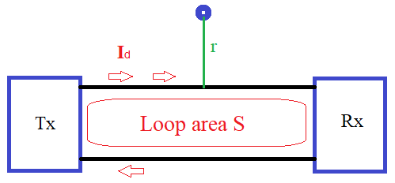

Figure 21: Differential mode radiation overview

## Material Selection for Hardware Design

### Common mode Choke

In electronic circuits, a common mode choke is used to suppress common mode noise and is considered as an electrical filter. It blocks the high frequency noise and allows the low frequency signal to pass. The common mode noise (CM) is radiated from sources and causes interference problems in electronic circuits [12]. There are basically two types of chokes. Single choke is used for suppressing differential mode noise, and a common mode (current compensated) choke is used for suppressing common mode noise. In our work, we have used a common mode choke. In a common mode choke there are two or more windings i.e. three line windings or more are possible. Here we have used two identical windings or coils around a common core in different direction. The basic feature is that regardless of the number of windings, they are all on a common core.

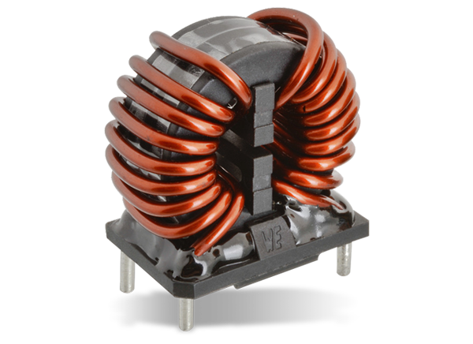

Figure 22: A Common mode choke

The windings are interconnected around this common core. The common mode choke has a common mode impedance that suppresses unwanted common mode noise. The common mode choke also has some differential mode impedance, which is called leakage inductance. Most importantly, the overall distortion of the total signal due to this leakage inductance is very low because the suppression does not occur at the frequency of the transmitted signal.

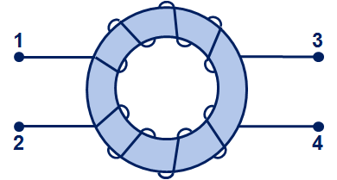 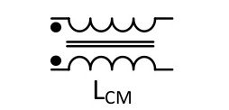

Figure 23: Physical layout and circuit schematic of a common mode choke

When a current flows into the CMC in the same direction, the two magnetic fields generated by these directional coils add up to a large inductance or impedance, which plays an important role in suppressing common mode noise.

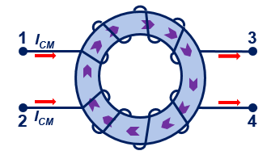 

Figure 24: Common mode current flow through common mode choke

When the currents flow in the opposite direction of the CMC, they produce two magnetic fields in opposite directions of the windings and cancel each other out. A very low inductance or impedance is then created in the inductor, called leakage inductance, but the core does not go into saturation even with large input currents.

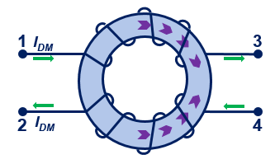

Figure 25: Differential mode current flow through common mode choke

When a CMC is designed for the filter purpose in the circuit, it attenuates the energy down to a given frequency, which reduces the unwanted noise going to the load. On that time choke produce a large inductance and common mode noise are filtered out only. But the differential mode signal induced from the choke leakage inductance also pass through the filter.

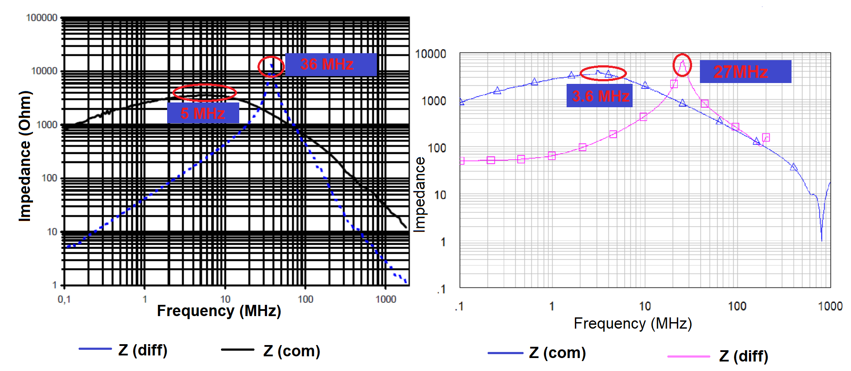

Figure 26: Impedance of a Common Mode Choke a. Measured b. Theory.

### Lumped elements

EMI filter is designed with two capacitors connecting between the line and the neutral wires (called X capacitor), and two capacitors connecting between the line to the ground and the neutral to the ground wires (called Y capacitor), and a common mode choke. Due to the CM and the DM noise current directions, CM choke and the Y-caps (CY1 and CY2) affect both CM and the DM emissions while the X-caps (CX1 and CX2) affect the DM noise. When the CM noise propagates through the EMI filter, CM noise is suppresses by the equivalent CM filter. At the same time, the DM noise is eliminated by the equivalent DM filter, which is a π-configuration filter. The equivalent CM filter comprises the CM inductance (LCM) of the CM choke at the load side and the parallel of CY1 and CY2 at the power supply side. The equivalent DM filter resulted from the total leakage inductance of two windings of the CM choke (LDM), the CX2 at the load and the CX1 at the supply side.

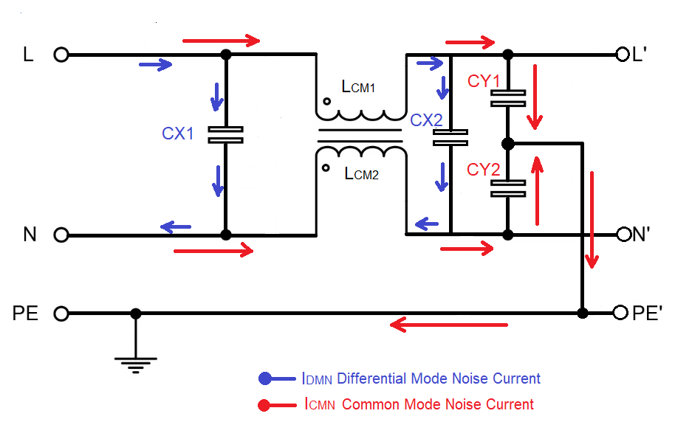

Figure 27: Lumped elements and current directions through them

## Noise Source Design

In an electrical system, noise is an unwanted signal that may be generated during transmission, processing, reception, storage, or conversion of signals. In an electromagnetic system, noise produces harmonics that distort the main signal in order to pass it on.

In our report, we have considered a loss-pass signal generator called a comb generator. A comb is a signal generator that produces multiple harmonics with similar amplitudes on the input side. However, at the output, the spectrum analyzer displays the signal like a comb, which is why it is also called a comb generator [13]. We used a comb generator that can produce a signal frequency of up to 1 GHz in an interval of 12 MHz. That is, we get a response at 12 MHz, 36 MHz, 60 MHz, 84 MHz, 108 MHz, 132 MHz, 156 MHz, 180 MHz, 204 MHz and so on. While we get the signal response, we get harmonics at exactly 24 MHz, 48 MHz and so on.

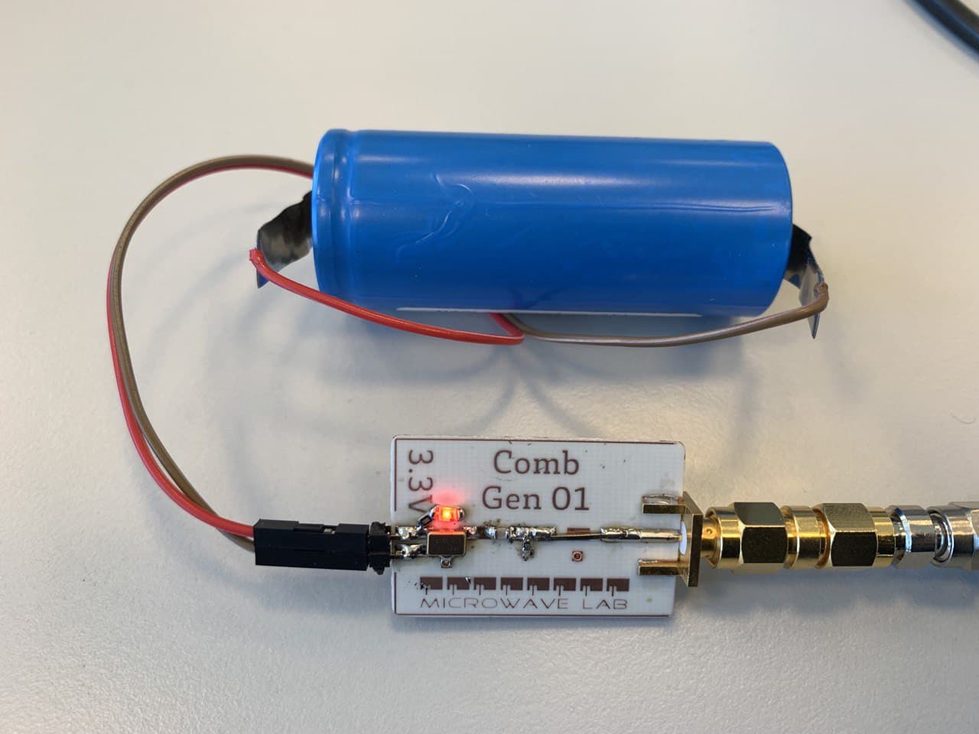

Figure 28: Noise signal generator (Comb generator), physical and circuit layout.



Figure 29: Hardware design of a Comb generator and the input power with frequency.

Discussion: As the magnitude of the comb generator should have the same power for the overall harmonics but here we have got variations in power for different frequencies. Although, these variations in power do not have a significant effect on our measurement.

## Line Impedance Stabilization Network (LISN)

LISN is used to measure how strong the radio transmitter is when the RF emissions enter through the power lines. LISN ensures that the power supply to the device under test is not interrupted and passes all emissions to the resistive load. The spectrum analyzer makes the measurement that the load receives.

LISN is designed to provide constant line impedance over a range of frequencies. It also minimizes the measured noise generated by the EUT. If we want to measure the performance of the LISN, it is important to know how much the external RF emission is attenuated by the LISN from the power supply [14]. And how much the RF emission is attenuated from the EUT to the measurement device.

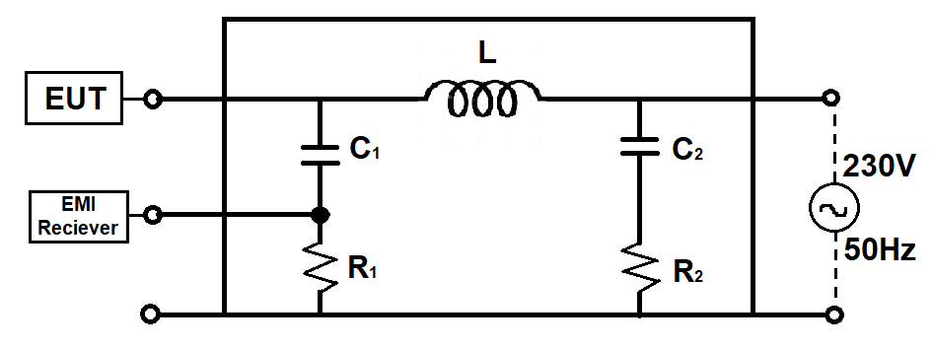

Figure 30: Circuit diagram of LISN

# Chapter Four: Filter Behaviour Prediction

## Linear Simulation

### S-parameter measurement

S-parameters consists of two fundamental topics:

* Two-port networks,
* Reflections on transmission lines.

#### Two-port network

It is the most commonly used circuit analysis technique that provides an equivalent circuit model for the specified terminal pairs of the network. The basic principle of two-port network analysis is to calculate only the terminal variables (input voltage, input current and output voltage, output current) instead of calculating the voltages and currents of all points within the circuit [15]. In EMC, two-port network analysis calculates the voltages and currents in sinusoids at each frequency described by their amplitudes and phases.

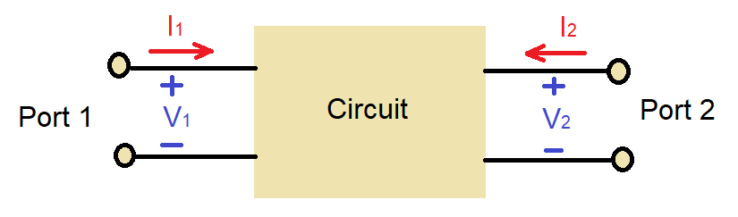

Figure 31: Two port network diagram

In a two-port S-parameters we can get four individual parameters which are:

S11 is the input voltage reflection coefficient

S12 is the reverse voltage gain

S21 is the forward voltage gain

S22 is the output voltage reflection coefficient.

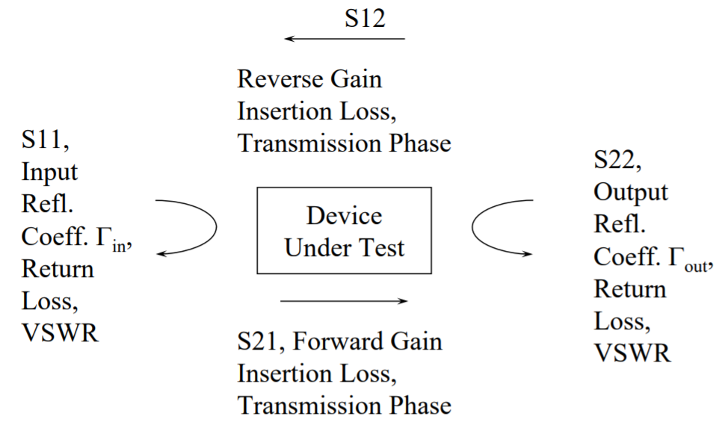

Figure 32: Definitions of four individual S-parameters.

To design and simulate an EMI filter connected to a noise generator, we performed a linear simulation. This linear simulation includes finding the S-parameters of the common mode choke and capacitors. We also had to measure the S-parameters of the common mode filter and the differential mode filter. We used a vector network analyzer to measure all these parameters.

The measured S-parameters of the designed common mode filter and differential mode filter are given in Figure 33. Comparison between Common Mode Filter and Differential mode filter in Software and Hardware simulation are countable.

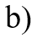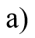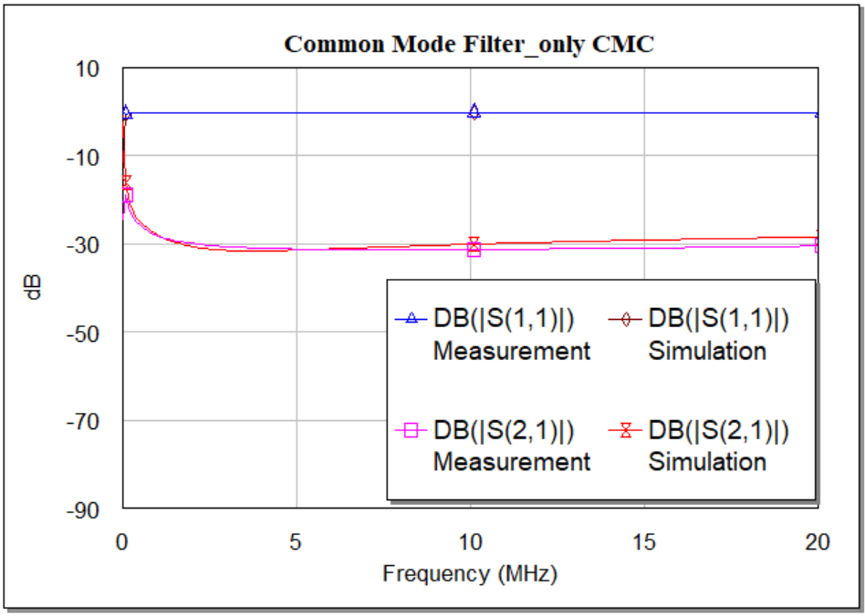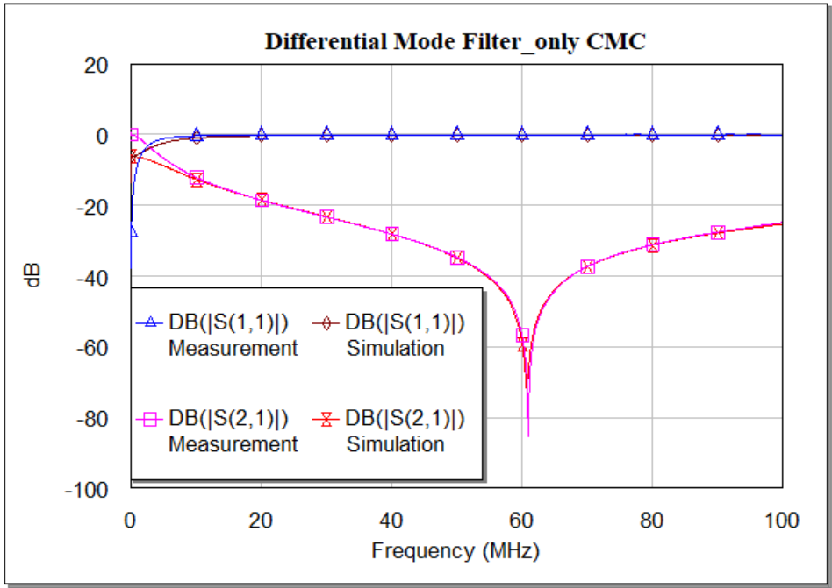

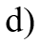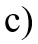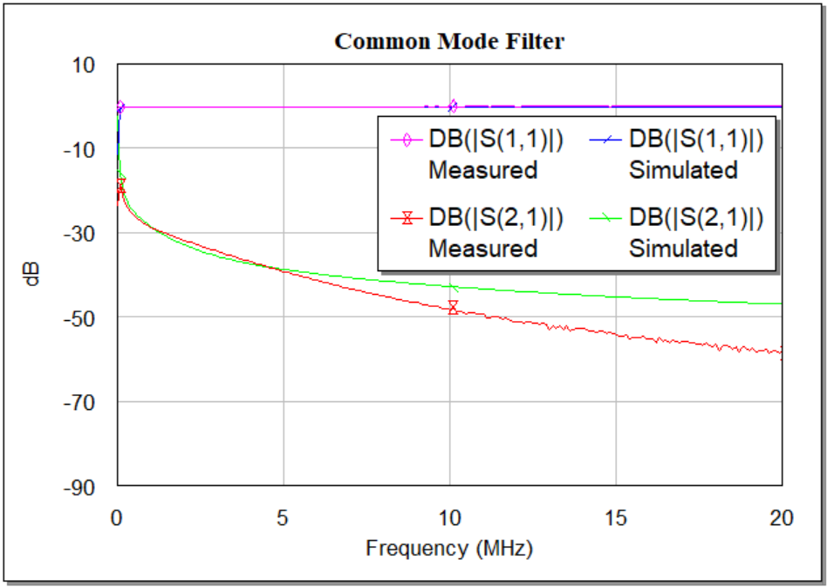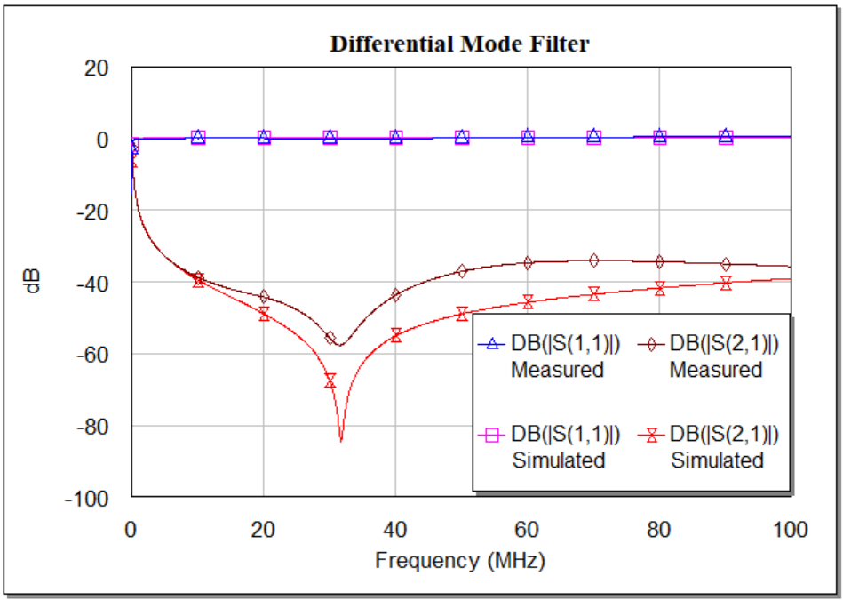

Figure 33: S-parameters measurements of CMF and DMF and comparison between measured and simulated measurements in dB.

Discussion: Determination of S-parameters is an important part of RF measurements. In the software simulation when a measure some response of a device then we definitely get some variation with the hardware measurements. For designing a common mode filter and a differential mode filter we have simulated in software. We have designed these filters using common mode choke and capacitors. There are some basic reasons for the variations of measured and simulated results. One of the basic reason is capacitance. As we know every single components has its own capacitance whatever it is SMA connector or other components we have used in designing the filter. Another reason is resistivity. In the software simulation, some values have changed due to the port resistance. In Figure 33, we have measured the overall S-parameters of the common mode filter and differential mode filter we have designed in the hardware platform. Figure 33 a) and b) are those two filter having only common mode choke. As we know common mode choke is designed to minimise the common mode noise and partial differential mode noise due to induced leakage inductance. Figure 33 c) shows a proper common mode filter having the nice shape of response both hardware and software platform. Although, in practical the insertion loss is higher. Figure 33 d) represents the differential mode filter in both platform and here after 7 MHz the transition occurs.

**Transfer function analysis**

The transfer function is the simplest way to summarize the behavior of a filter. It determines how an output signal relates to the input signal at a given frequency. An EMI filter allows low-frequency AC signals to flow through the circuit. The output signal of the filter is attenuated depending on the frequency of the input signal. A number of elements are used to construct filter circuits with different characteristics. The transfer function can be easily determined from a graph of the output signal at different frequencies and can be easily calculated using Kirchhoff's laws [16].

$H\left(f\right)=\frac{V_{out}\left(f\right)}{V_{in}\left(f\right)}; \left|H\left(f\right)\right|= \left|\frac{V_{out}\left(f\right)}{V_{in}\left(f\right)}\right|; θ=arg H\left(f\right)$ (7)

The voltage and current of the input and output can be measured using the S-parameters. However, a different parameter analysis is used for this purpose, which is called the ABCD parameter matrix. During a signal transmission, many losses can occur in the transmission line which reduce the efficiency of the line. All these parameters are used to minimize the losses. The conversion of S- parameters to ABCD parameters can be done using equation 8, equation 9, equation 10 and equation 11.

A = $\frac{\left(1+S_{11}\right)\left(1-S_{22}\right)+S_{12}S_{21}}{2S_{21}}$ (8)

B = $Z_{0}\frac{\left(1+S_{11}\right)\left(1+S_{22}\right)-S_{12}S_{21}}{2S_{21}}$ (9)

C = $\frac{1}{Z_{0}}\frac{\left(1-S_{11}\right)\left(1-S_{22}\right)-S_{12}S_{21}}{2S_{21}}$ (10)

D = $\frac{\left(1-S_{11}\right)\left(1+S_{22}\right)+S_{12}S_{21}}{2S_{21}}$ (11)

As all the S-parameters are set of data in phasor form, so ultimately we will obtain ABCD matrix in phasor form also. Here Z0 is called the line impedance which is considered as 50Ω. The voltage and current can be calculated using the following formulas:

(12)

So, V1 = AV2 + BI2 (13)

I1 = CV2 + DI2 (14)

When a signal passes through the filter, the output signal is phase shifted with respect to the input signal. This means that a transfer function is a complex function of frequency. It contains all the information to determine the magnitude of the output signal and its phase.

We can easily calculate the transfer function using the ABCD parameter. The ABCD matrix can be calculated using the S- parameter. So, to obtain the transfer function from the ABCD parameters, we can use Equation 15, where the source impedance and the load impedance are both 50 Ω.

$H\left(f\right)=\frac{V_{out}\left(f\right)}{V_{in}\left(f\right)}=\frac{Z_{L}}{AZ_{L}+B+CZ_{S}Z_{L}+DZ_{S}}$ (15)

As ABCD parameters are complex quantities and frequency dependent, the transfer function will also have a complex phase and magnitude as a function of frequency. Putting the value of ZL and ZS we can find the value of ABCD parameter and then we can find transfer function as well. As S-parameters are complex, so we have used MATLAB to plot the transfer function.



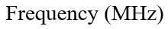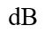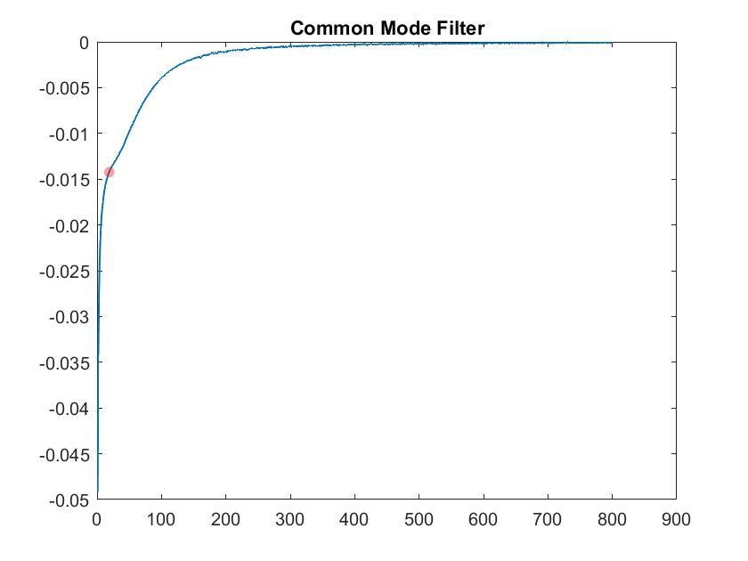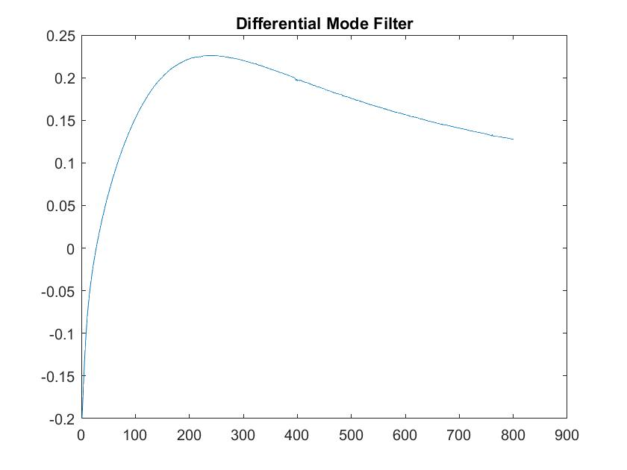



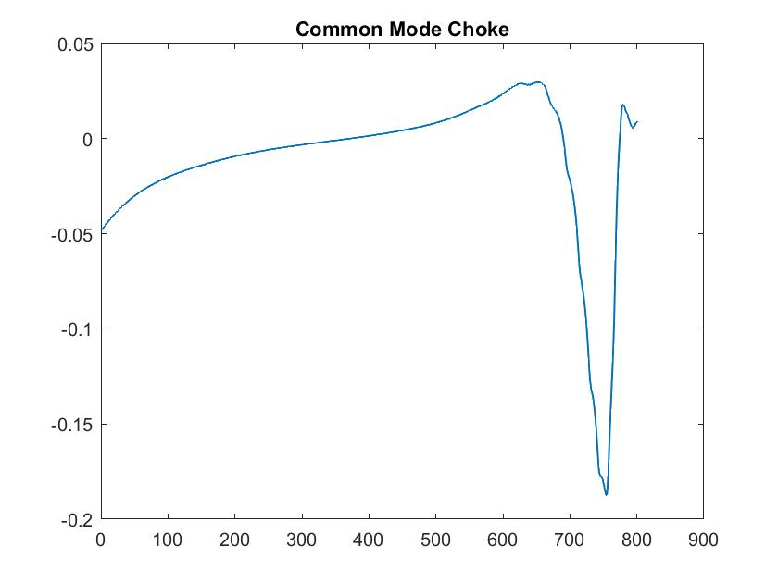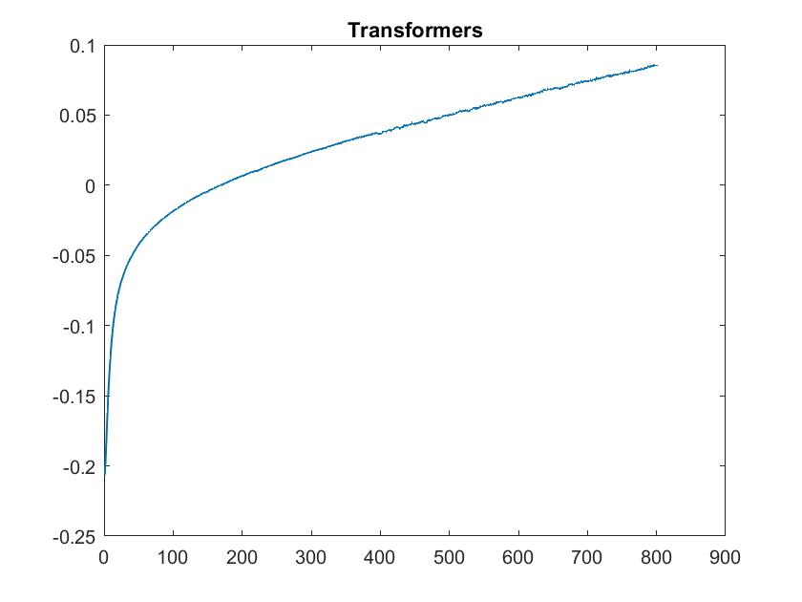

Figure 34: Transfer functions of a) common mode filter, b) differential mode filter, c) common mode choke, d) transformers.

Discussion: In Figure 34, we have got the transfer function of the common mode filter and differential mode filter. As well as the transformer that we are using alone with the differential mode filter. We have completed this simulation using hardware measured data. That is why we have got some mismatches for both common mode filter and common mode choke.

### Reflections on transmission lines

A two-port network is referred to as a system network that has two input ports and two output ports. Two input ports are connected to the source and the other two are connected to a load of the circuit. These input and output ports are balanced, so if you swap the input and output ports, the overall transmission characteristics will not change. The transmission line depends on the dimensions, thickness, and spacing of the components, which must be very accurate, and the impedance matching must also be correct to minimize the transmitted and reflected power loss. In a RF system, the transmission line losses can be specified by calculating the S-parameters of the whole network. The S-parameters are mainly influenced by the characteristic impedance ZC of the network and the propagation constant 𝛾 [17].

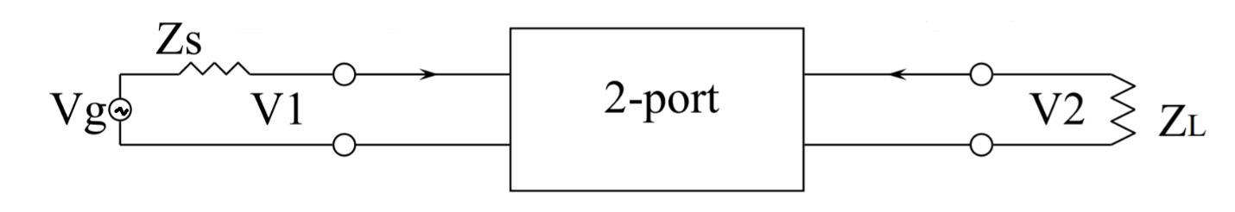

Figure 35: Transmission line of a two-port network

The interchanging of these two-port cannot change the transmission line S-parameters except these three factors:

* Frequency
* Characteristic impedance
* Line geometry

The characteristic impedance ZC and the propagation constant 𝛾 can be calculate by equation 16 and equation (17).

$Z_{C}= \sqrt{\frac{R+jωL}{G+jωC}}$ (16)

$γ=\sqrt{(R+jωL)(G+jωC)}$ (17)

Here, R, L, G, and C all are the distributed elements of the transmission line.

#### Insertion Loss Measurement

On its way down a transmission line to a component or circuit, a signal loses some power due to noise or component limitations. When the RF signal is transmitted from one port to another port, the total power loss is called insertion loss.

Insertion loss is the ratio between the output power and the input power [18]. It is measured in decibels (dB). The formula for determining insertion loss is as follows:

Insertion Loss = 10 $\log_{10}\left[\frac{P_{out}}{P_{in}}\right] dB$ (18)

Insertion loss can be measured using the S parameter. It is denoted by S21. Equation (18) can thus also be written in terms of the S parameter as follows:

Insertion Loss = -20 $\log_{10}\left|S_{21}\right| dB$ (19)

The insertion loss of the common-mode filter and the push-pull filter (ILDM and ILCM) can be determined by subtracting the emission limit from the measured DM and CM noise levels without filter.

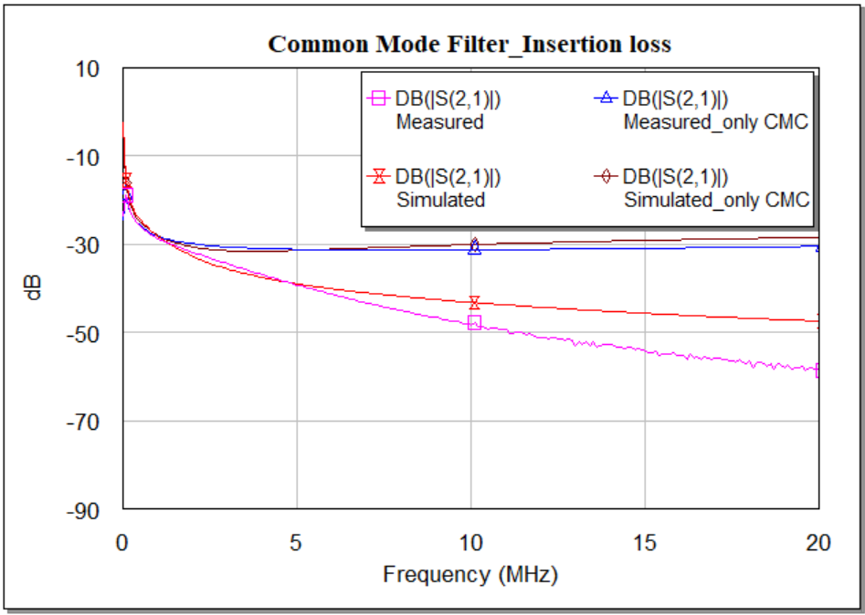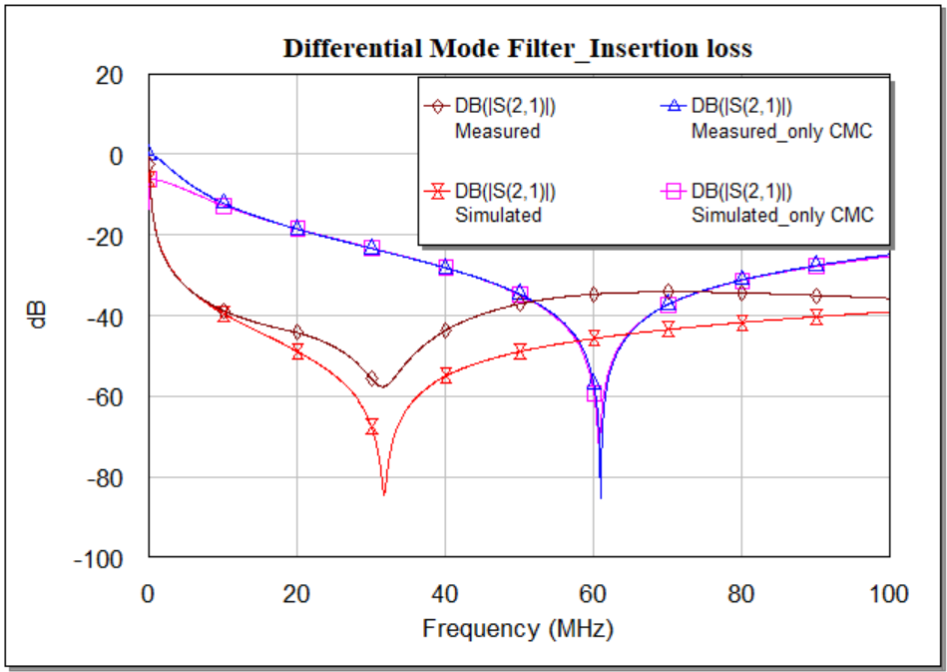

Figure 36: Insertion loss measurement of CM and DM filter in Hardware (measured) and Software (simulated) platform.

Discussion: Insertion loss for both common mode and differential mode filters are plotted in Figure 36. The insertion loss for the differential mode filter in software simulation is a little bit higher than in the hardware simulation. But for the common mode filter, the amount of loss is quite similar till 5MHz. After that, the loss is higher in hardware just because of the component's own losses.

#### Reflection Loss Measurement

When a generated signal is to be passed through a transmission line, some of the energy is reflected back to the source. This lost energy is called reflection loss. Reflection loss can occur due to an impedance mismatch of the input and output signals. Sometimes this mismatch occurs only in the cables if they are damaged or spliced. When this loss is higher, a very small amount of energy is transmitted. A high reflection loss sometimes damages internal components.

Figure 40 shows how a forwarded power Pfwd is partially reflected to the load as Pload and partially reflected to the source as Pref.

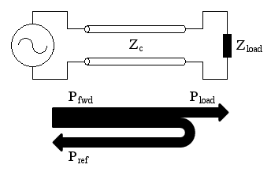

Figure 37: Power is reflecting to the source [19].

We can measure the reflection loss in terms of signal power if we know the forward power or incident power (Pincident / Pfwd) and the reflected power (Pref).

Reflection Loss = 10 $\log_{10}\left[\frac{P_{reflected}}{P_{incident}}\right]dB$ (20)

From the S-parameters we can easily calculate reflection loss.

Reflection Loss = $\left|S_{11}\right|$

There is a difference between return loss (RL) and the reflection coefficient ${ S}_{11}$. RL in dB is 10 $\log_{10}\left[\frac{P_{incident}}{P_{reflected}}\right]$. So the relation between return loss and reflection loss is,

Reflection Loss (dB) = - Return loss (dB)

In our EMI filter design work we have measured reflection loss both of the common mode filter and differential mode filter in hardware and software platforms on dB scale.

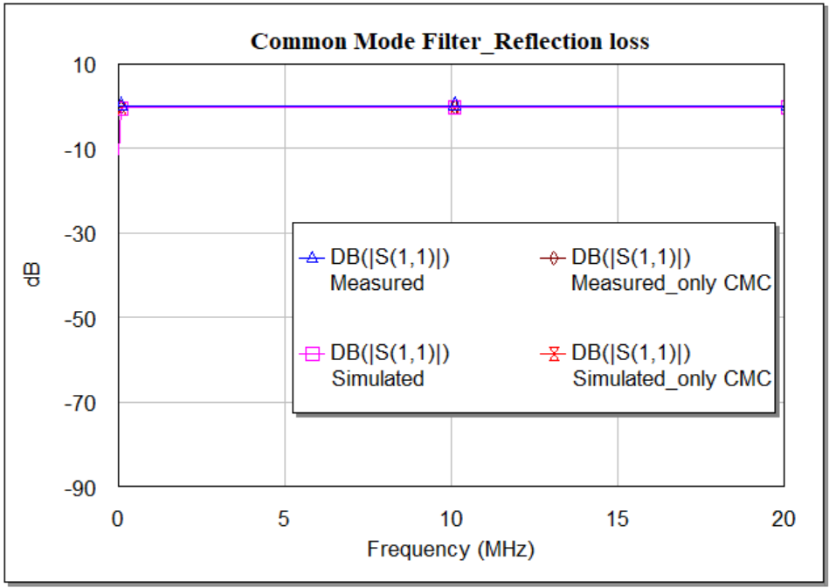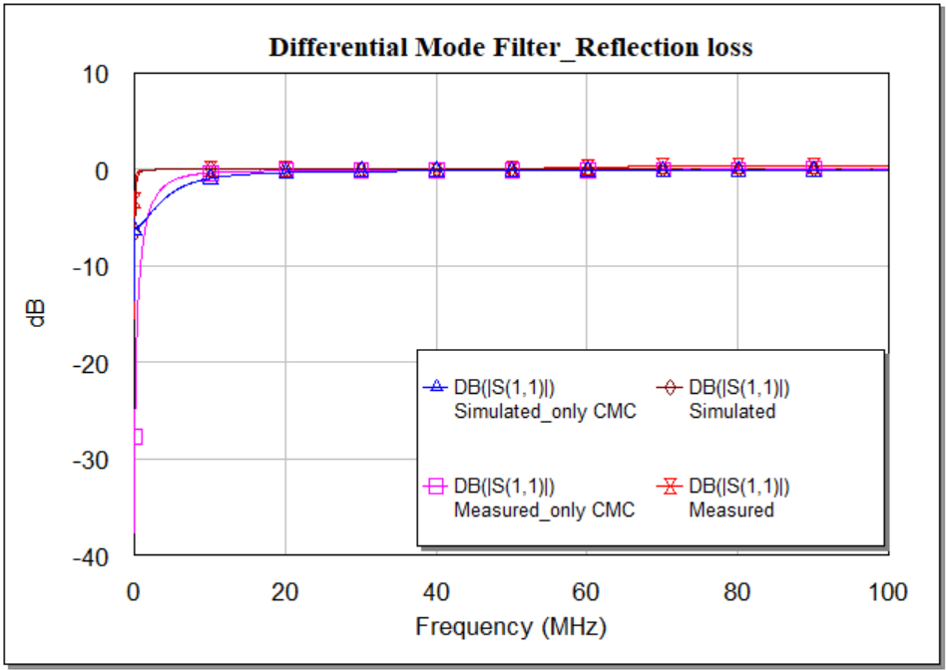

Figure 38: Reflection loss of common mode filter and differential mode filter.

Discussion: There is some reflection loss in the differential mode filter due to the signal nature and as it generates in between the line and neutral, it cannot be avoided. But for an efficient filter, the reflection loss in common mode is nearly zero. In Figure 38, the reflection loss for both of the filters is given in hardware and software platforms and the amount of loss is the same in both platforms.

## Nonlinear Behaviour

A periodic signal can be represented in both the time domain and the frequency domain. When this type of signal manage to operate a device into its nonlinear domain, the shape of the waveform becomes distorted. This behavior is different in the different domains. In the frequency domain, this distortion is caused by the change in harmonic. It is identified by the responses of the equipment under test (EUT). This EUT is inspired by a series of discrete tones which are relatively small. For this reason, the principle of superposition of harmonics can be correctly applied.

### Harmonic Balance Techniques

The Harmonic Balance (HB) algorithm is very widely used to solve nonlinear networks. The HB algorithm divides the main circuit into two subcircuits, a linear subcircuit and a nonlinear subcircuit. It is also called the frequency domain method for identifying the steady-state response. When a sinusoidal signal is applied to a nonlinear component in the system, this signal produces harmonics of the fundamental frequency in a certain range [20]. The fundamental simulation frequency (known as the input tone) is used to determine the number of harmonics required to accurately represent the nonlinear distortion. For a solver with one tone HB, analyses are only performed for a single frequency, such as Vin/Vout, Pin/Pout. For multiple tones, the analyses may include intermodulation distortion. Once the number of tones is defined, the HB solver divides the circuit into two subgroups, one linear and one nonlinear, and proposes a set of voltages at the intersection of these subgroups. These voltages are defined in the frequency domain. These voltages are then transferred to the time domain in nonlinear models and converted again to the frequency domain. If the simulation is to be performed over a frequency range, the sources should be updated accordingly and the algorithm repeated until the frequency set is covered.

### Time-Domain Analysis

The best way to find out how a filter will work is to simulate it in the time domain. This is a recently proposed technique that represents the response and simulates waveforms in the time domain. This technique is essential to determine signal distortion due to the nonlinearity of the device. The time domain solution is converted to the frequency domain using the fast Fourier transform (FFT). [22].

#### Voltage analysis

The best way to find out how a filter will work is to simulate it in the time domain. This is a recently proposed technique that represents the response and simulates waveforms in the time domain. This technique is essential to determine signal distortion due to the nonlinearity of the device. The time domain solution is converted to the frequency domain using fast Fourier transform (FFT). According to the continuity equation, the nonlinear currents are equal to the linear currents. The repeated equalization of the currents between the linear and nonlinear network nodes can drag out the simulation time, and sometimes it fails to converge.  
  
Since the whole filter is divided into two parts according to the noise level, each measurement is divided systematically.

##### Common Mode measurement

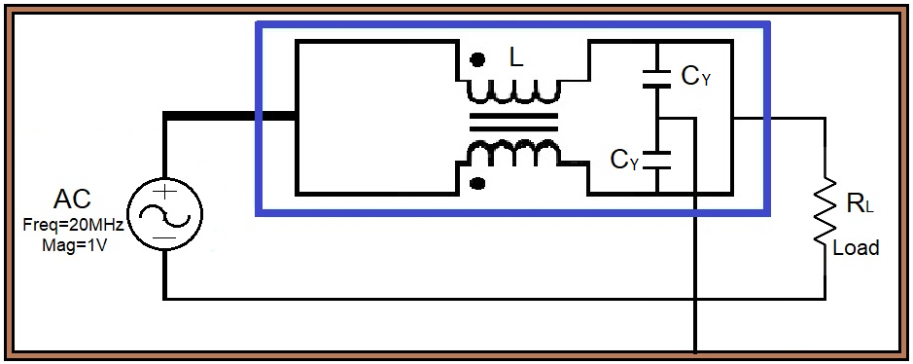

Figure 42: Circuit design of common mode voltage measurement in time domain.

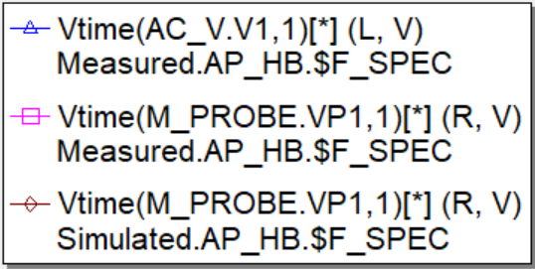 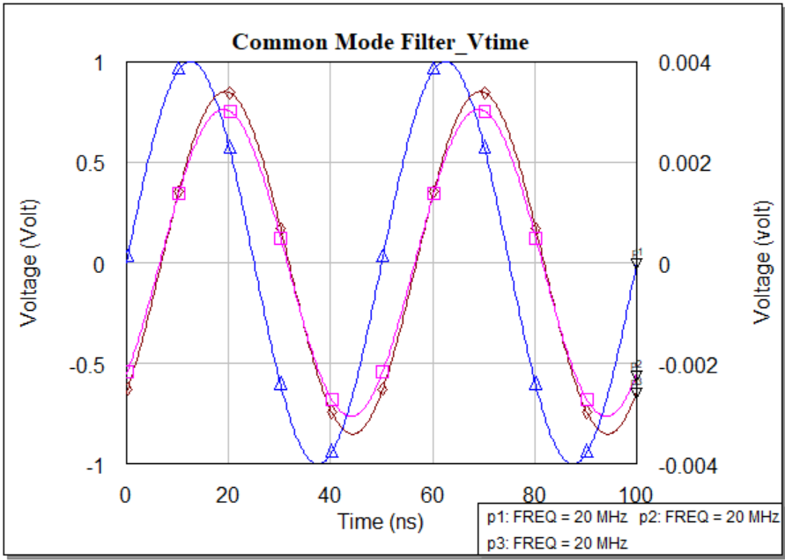

Figure 42: Common mode voltage measurement in time domain using different capacitor.

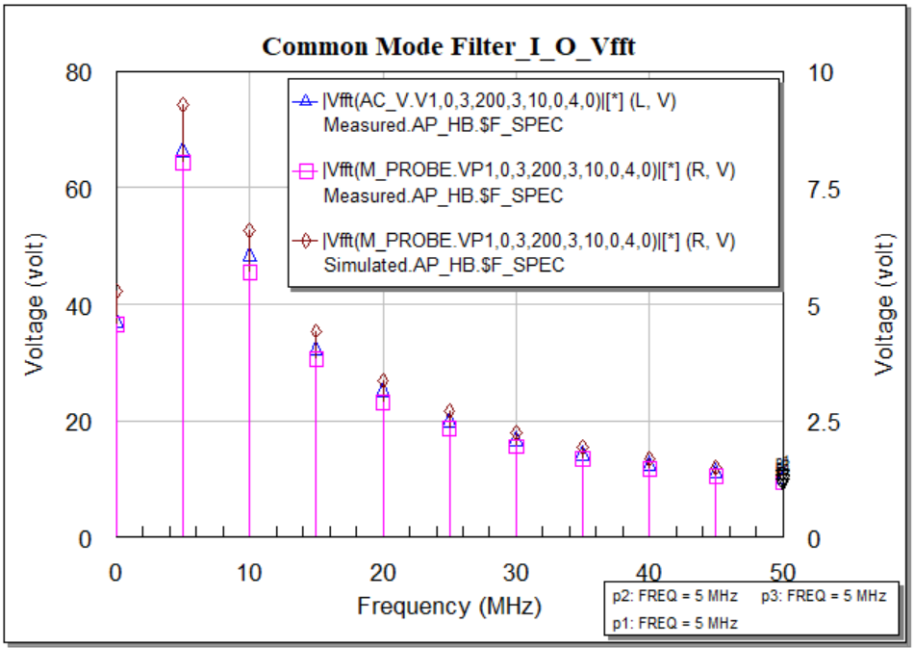

Figure 43: CM voltage measurement in Frequency domain using different capacitor

Discussion: According to the basic structure of a common mode, the signal is passing through both line and neutral. Due to the common mode choke the voltage is decreasing and at the output, we are getting low voltage. In the Figure 43, two sets of capacitors were being used as the Y cap. Where for the set of 100pF cap the voltage drop across the load is lower than the set of 2200pF. We can easily observe the result in FFT domain simulation.

##### Differential mode measurement

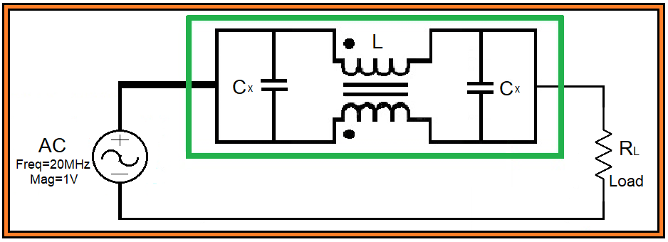

Figure 42: Circuit design of DMF voltage measurement in time domain.

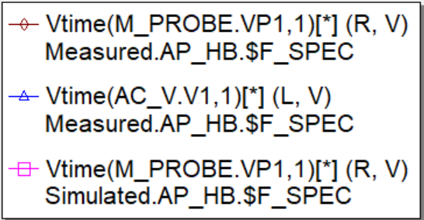 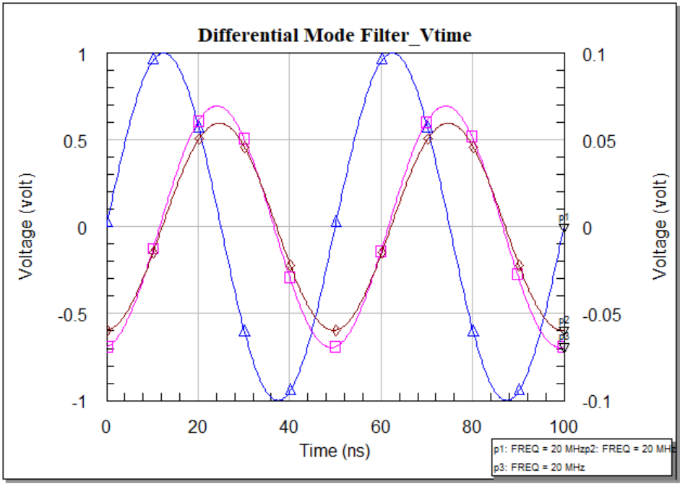

Figure 42: Differential mode voltage measurement in time domain using different capacitors.

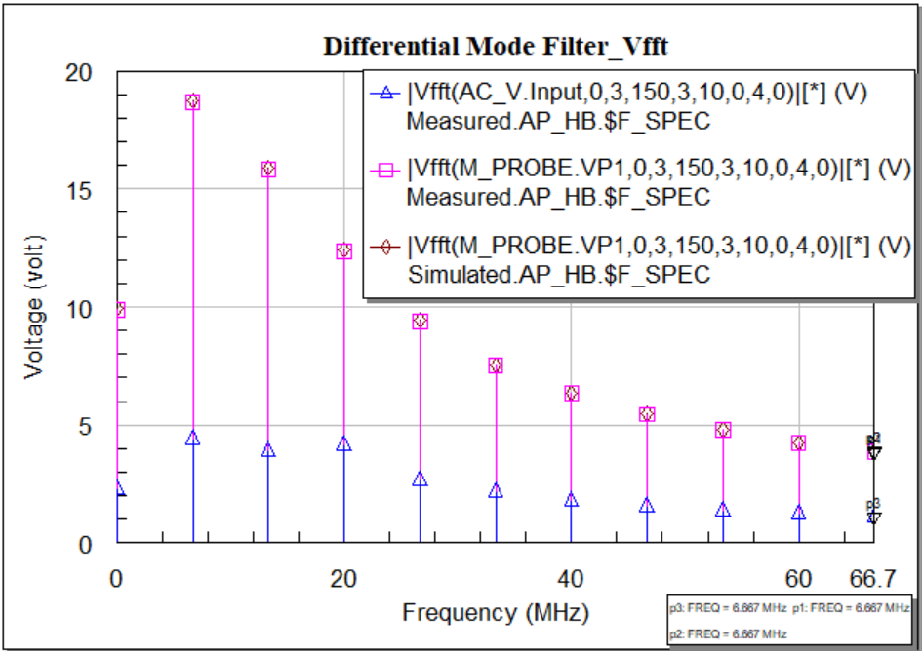

Figure 44: DM voltage measurement in Frequency domain using different capacitor.

Discussion: Differential mode noise is generated due to the source and leakage inductance of common mode choke. We have use two set of capacitors where the maximum voltage drop can be easily observed for set of 0.1uF instead of 840pF and 470pF capacitor.

#### Multi-tone Analysis

Multi-tone analysis is an advanced technique commonly used to test electronic devices, whether passive or active. In this paper, we have applied this test to a linear device such as an electromagnetic interference (EMI) filter. Multi-tone testing uses multiple tones to test the equipment under test (EUT) and this technique is more efficient compared to single tone and two tone testing [22]. This test involves the generation of multi-tone signals consisting of a summation of sine waves. These sine waves are different from the waves of the input signal. Only devices that meet the specification of the crest factor (CF), which is the ratio between the peak amplitude of the waveform and the value RMS.

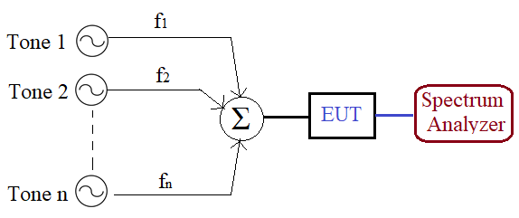

Figure 45: Multi tone measurement process

The change in amplitude and phase of a sinusoidal signal is not considered distortion. However, a complex, time-varying signal can drastically change amplitude and phase shift, distorting the waveform in the time domain. In a nonlinear device, the input signal can be shifted in the frequency domain and produce a new output signal in the form of harmonics. For the test, we used three sinusoidal signals as input signal. It is easy to see that the output signal is generated in the form of harmonics with different order [24].

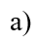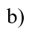 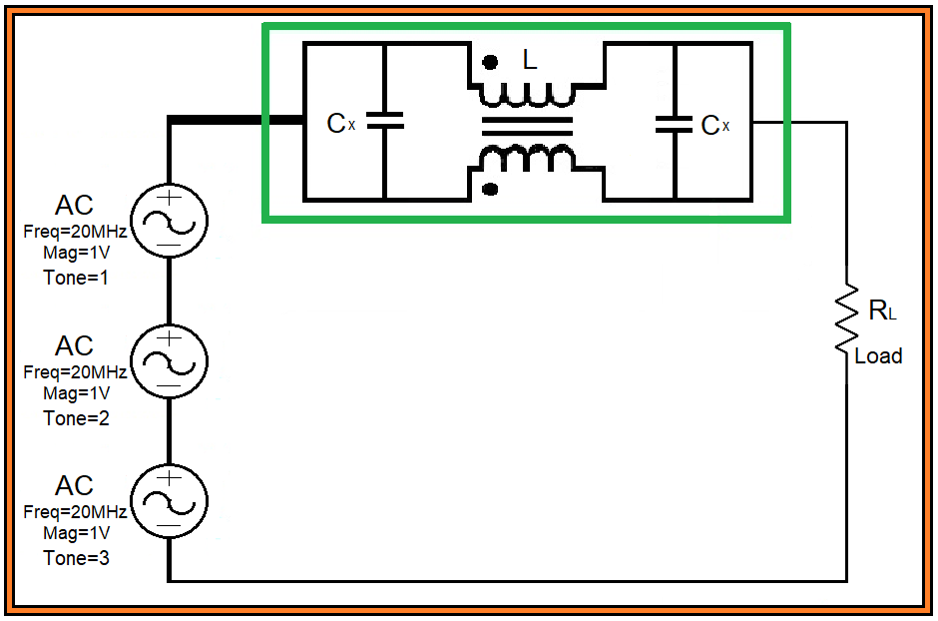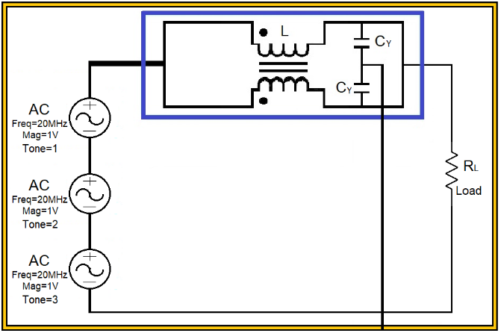

Figure 42: Circuit design of a) CM and b) DM filter with multi-tone signal source.

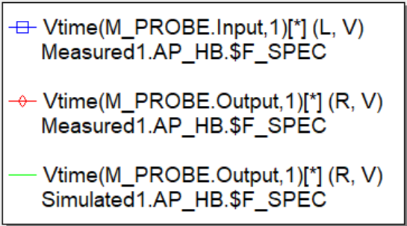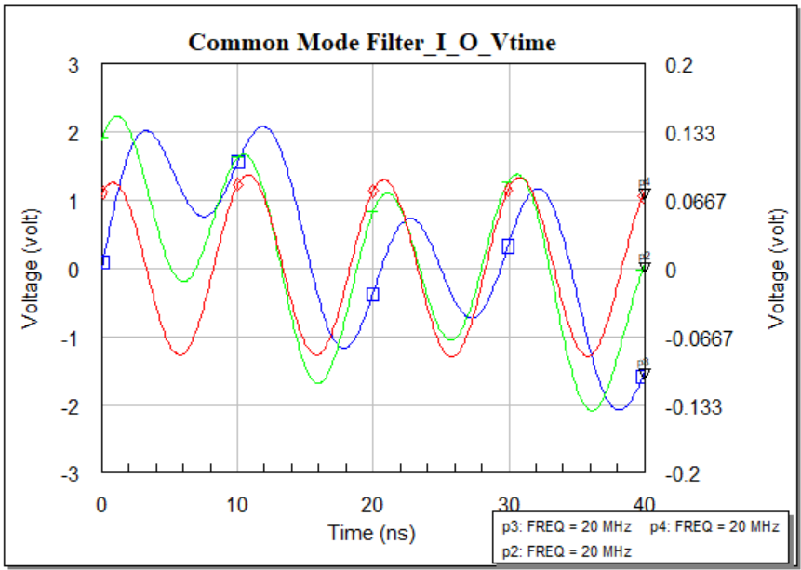

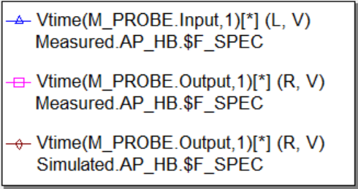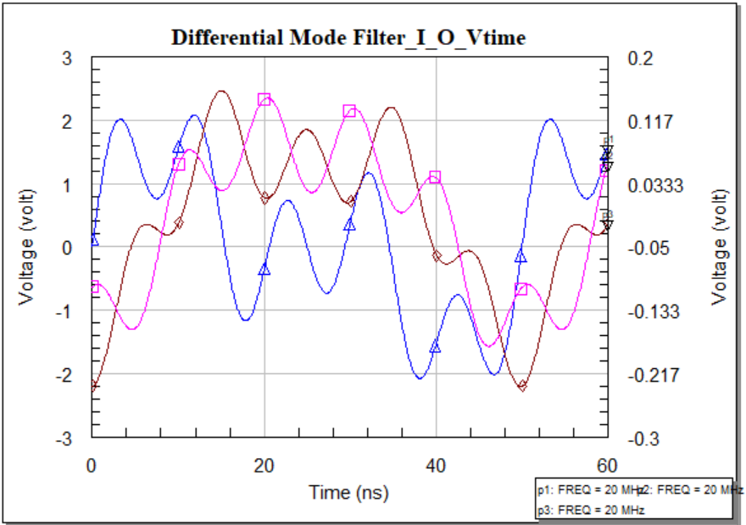

Figure 46: Voltage analysis of CM and DM filter for multi-tone input signal in time domain.

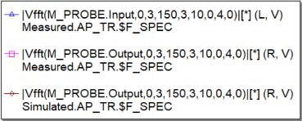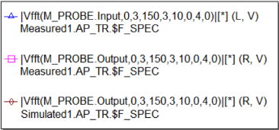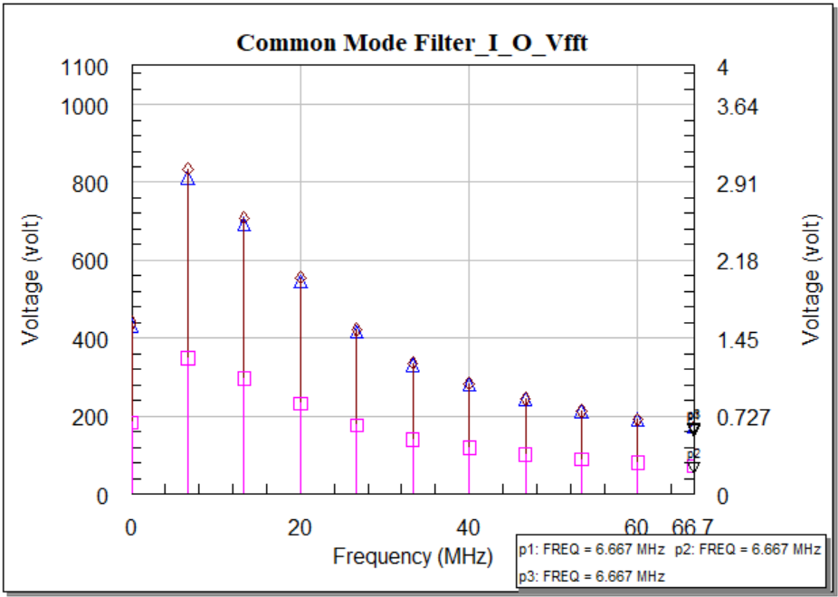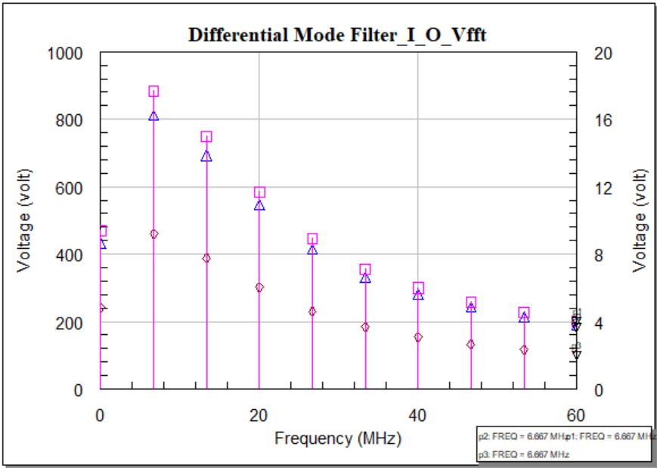

Figure 46: Voltage analysis of CM and DM filter for multi-tone input signal in frequency domain.

Discussion: A multi-tone signal means multiple sinusoidal signals having individual tones. The magnitude and the phase may the same but during the simulation in the time domain the input signal may look like Figure 46 c). In the outside of the common mode filter we get the simulated result for a set of 100pF and 2200pF capacitors, shown in Figure 46 d). It is clearly visible that the output of the filter for the set of 100pF capacitors has a higher magnitude than for the set of 2200pF. For the differential mode filter, the input signal also has a signal pattern like Figure 46 e) due to the multiple tones. Again we get distorted output because of the differential mode filter that is shown in Figure 46 f). In a multi-tone analysis, time-domain measurements estimate the distorted magnitude of a signal. Figure 46 has analyzed both time and frequency domain simulations. In the frequency domain, we have got the response of multi-tone input and output sinusoidal signal for both common mode and differential mode filter for two sets of capacitors. Frequency domain means the response that we have got in the time domain, converts to fast furrier transform. For that reason, we will only get responses at the frequency that is set for each tone individually. The magnitude will vary as it varied in the time domain.

#### Power analysis

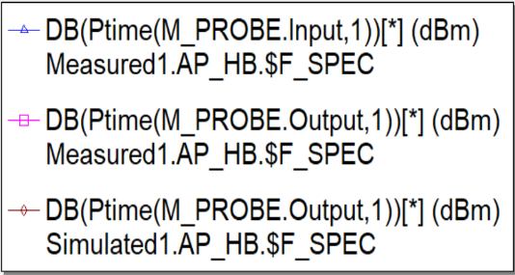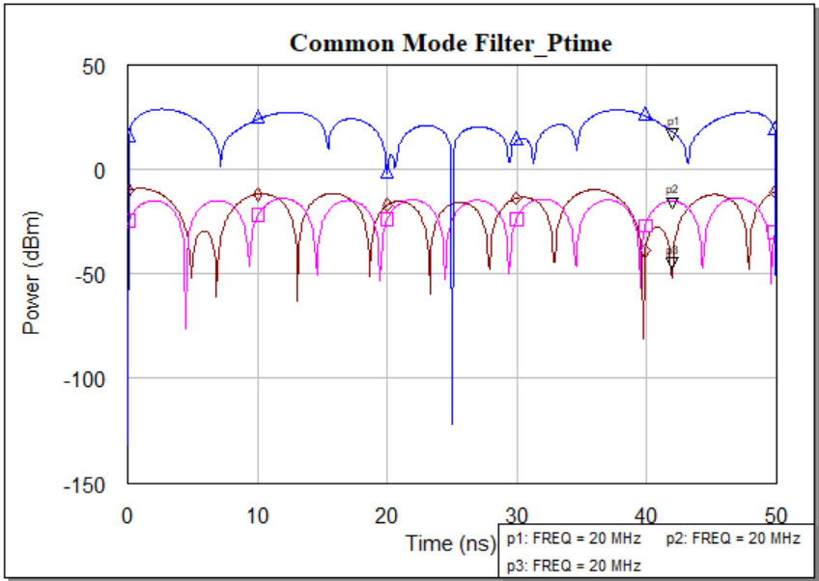

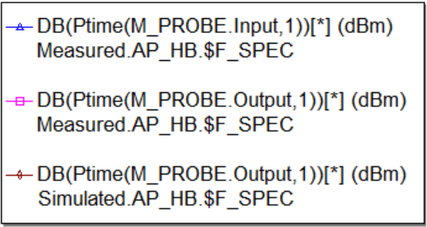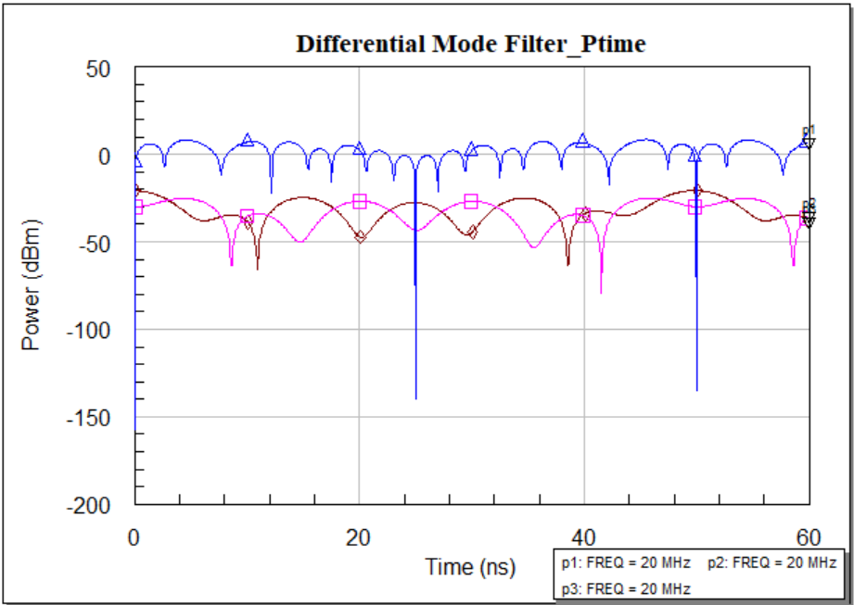

Figure 46: Power analysis of CM and DM filter for multi-tone input signal in time domain.

|  |  |  |  |  |
| --- | --- | --- | --- | --- |
| Frequency  (MHz) | Noise power (dBm) | Output power  (no cap) dBm | Output power  (2X100pF) dBm | Output power  (2X2200pF) dBm |
| 12 | -18.50 | -48.6 | -52.7 | -75.2 |
| 36 | -18.50 | -50.3 | -52.1 | -78.1 |
| 60 | -19.5 | -42.8 | -60.6 | -86.4 |
| 84 | -20.3 | -48.3 | -58.1 | -85.2 |
| 108 | -22.6 | -44 | -65.3 | -90.5 |
| 132 | -22.9 | -53.7 | -70.8 | -92.8 |
| 156 | -23.5 | -51.1 | -67.5 | -84.3 |
| 180 | -26.1 | -46.3 | -69.6 | -83.0 |
| 204 | -27.8 | -47.3 | -67.7 | -78.1 |
| 228 | -29.6 |  | -74.0 | -81.2 |

Table 01: Hardware measurement of CMF with 2 set of capacitors

|  |  |  |  |  |
| --- | --- | --- | --- | --- |
| Frequency  (MHz) | Noise power (dBm) | Output power  (no cap) dBm | Output power  (1X100nF) dBm | Output power  (820pF &470pF) dBm |
| 12 | -18.50 | -24.6 | -49.1 | -29.5 |
| 36 | -18.50 | -35.6 | -51 | -47.6 |
| 60 | -19.5 | -33.8 | -44.9 | -59.6 |
| 84 | -20.3 | -38.6 | -47.3 | -48.1 |
| 108 | -22.6 | -33.7 | -41.3 | -48.2 |
| 132 | -22.9 | -41.1 | -47.9 | -45.2 |
| 156 | -23.5 | -31.3 | -37.3 | -37.9 |
| 180 | -26.1 | -30.4 | -34 | -31.1 |
| 204 | -27.8 | -30.8 | -34.4 | -33.9 |
| 228 | -29.6 |  |  |  |

Table 02: Hardware measurement of DMF with 2 set of capacitors

 

Figure 47: a) Hardware simulation for CM filter, b) Hardware simulation for DM filter.

|  |  |  |  |  |  |  |
| --- | --- | --- | --- | --- | --- | --- |
| Frequency  (MHz) | Noise power (dBm) | Output power  (no cap) dBm | Output power  (2X100pF) dBm | | Output power  (2X2200pF) dBm | |
| Sym com | real com | Sym com | real com |
| 12 | -18.46 | -54.03 | -56.02 | -65.36 | -78.37 | -78.32 |
| 36 | -18.46 | -51.08 | -59.02 | -63.58 | -85.31 | -85.79 |
| 60 | -19.46 | -49.77 | -61.67 | -63.56 | -88.58 | -93.14 |
| 84 | -20.24 | -48.44 | -63.13 | -63.7 | -92.7 | -97.99 |
| 108 | -21.1 | -47.32 | -64.12 | -64.31 | -96.25 | -112.1 |
| 132 | -22.85 | -47.52 | -66.05 | -66.38 | -103.1 | -97.47 |
| 156 | -23.47 | -46.74 | -66.74 | -67.25 | -113.7 | -91.5 |
| 180 | -26.08 | -48.14 | -69.57 | -70.34 | -105.8 | -89.75 |

Table 03: Software measurement of CMF with 2 set of capacitors

|  |  |  |  |  |  |  |
| --- | --- | --- | --- | --- | --- | --- |
| Frequency  (MHz) | Noise power (dBm) | Output power  (no cap) dBm | Output power  (1X100nF) dBm | | Output power  (820pF &470pF) dBm | |
| sym com | real com | sym com | real com |
| 12 | -18.46 | -37.53 | -33.59 | -39.71 | -43.07 | -42.61 |
| 36 | -18.46 | -45.77 | -62.45 | -65.51 | -59.07 | -57.65 |
| 60 | -19.46 | -49.01 | -69.25 | -70.41 | -63.94 | -61-94 |
| 84 | -20.24 | -49.82 | -71.29 | -73.2 | -61.14 | -57.63 |
| 108 | -21.1 | -49.33 | -71.37 | -74.71 | -54.47 | -61.0 |
| 132 | -22.85 | -49.01 | -71.36 | -73.88 | -70 | -73.52 |
| 156 | -23.47 | -46.61 | -69.17 | -71.25 | -74.39 | -78.23 |
| 180 | -26.08 | -45.16 | -67.87 | -69.77 | -77.35 | -81.99 |

Table 04: Software measurement of DMF with 2 set of capacitors



Figure 48: a) Software simulation for CM filter, b) Software simulation for DM filter



Figure 49: Noise power for both filter both in Software and Hardware platform

Discussion: Power measurement is a very important part of this thesis work. Figures 47, 48 have been plotted according to these values that we already mentioned in tables 1 to 4. Observing these figures, we can estimate that the output response is close to the input response for those capacitor sets proposed. That means the power loss is lower for those capacitor sets, we have proposed. This observation is suited both for the hardware and software simulations. On the other hand, we also have power measurement for the noise source that we have built manually both in hardware and software. That has been plotted in Figure 49.

#### Measurement Comparison

##### Common Mode Filter





Figure 50: Comparison between Hardware and Software simulation with different components.

##### Differential Mode Filter





Figure 51: Comparison between Hardware and Software simulation with different components.

Discussion: An Electromagnetic Interference (EMI) filter is consist of two basic part, which are the Common mode part and the Differential Mode part. These two-part can be implemented individually considering all the parameters and simulation process in an equal manner. In this thesis work, we have implemented these two basic parts of an EMI filter and tested the variation in frequency domain replacing the parasitic components (capacitors). For a common mode part, the hardware and the software testing has been considered as following three criteria:

* Considering the common mode choke as a common mode filter,
* Considering the parasitic components value as they are being used in the market,
* Considering the parasitic components value focusing only on the trigger point.

# Chapter Five. Experimental approach and discussion

## Case Study 1: 230V 50Hz line

A common mode power line choke will be used to perform this case study where the inductance value is 2.2 mH and the rated voltage is 250V at 50Hz. A LISN network we have used as a Load. The schematic of a LISN have already shown in Figure 30 and the values of the components remain same. We are going to take the linear and nonlinear measurements using the same EMI filter standard design we have previously used across the LISN. The same X and Y capacitor set will be used to observe the variety of responses both in the Frequency and Time domain. A different common mode choke is used to complete the case.

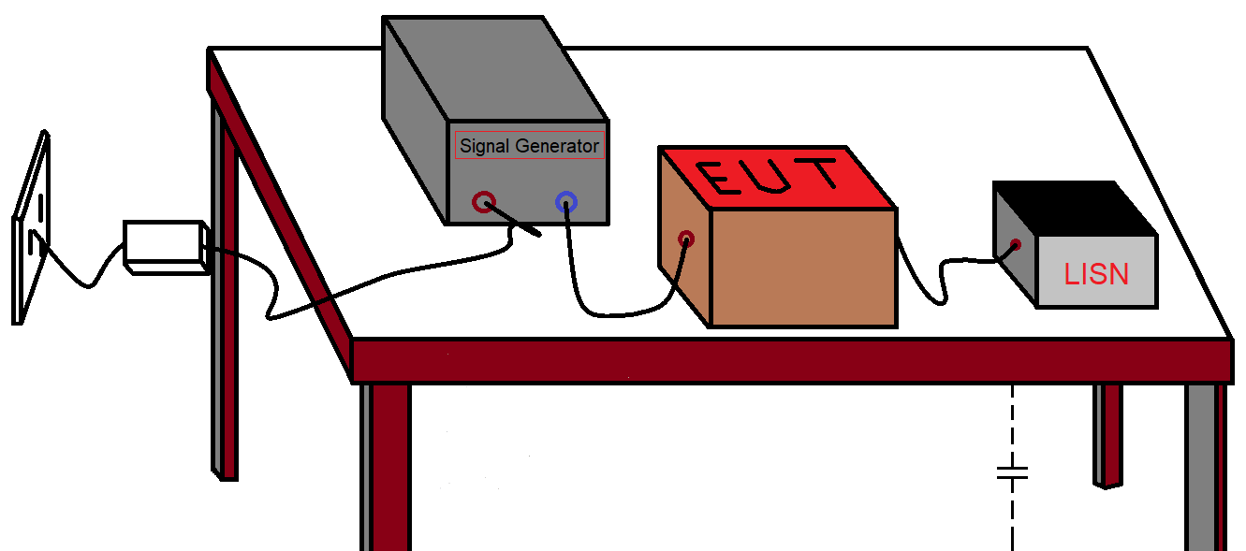

Figure 52: Model setup for the test.



Figure 53: Circuit setup for the test.

### Linear simulation

In the linear operation the insertion loss will be ensured both in common mode filter and differential mode filter using 2 set of capacitors. The results will be compared for both cases.

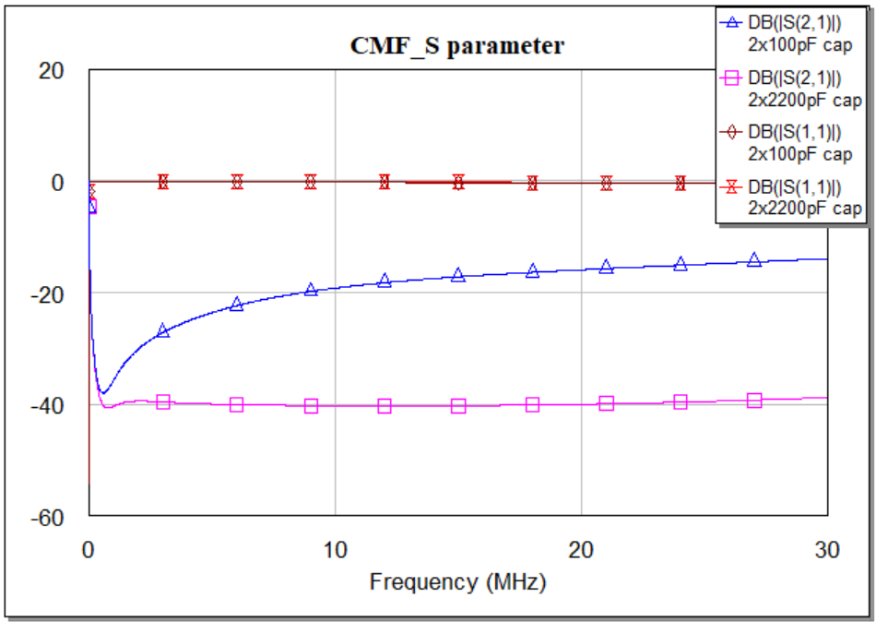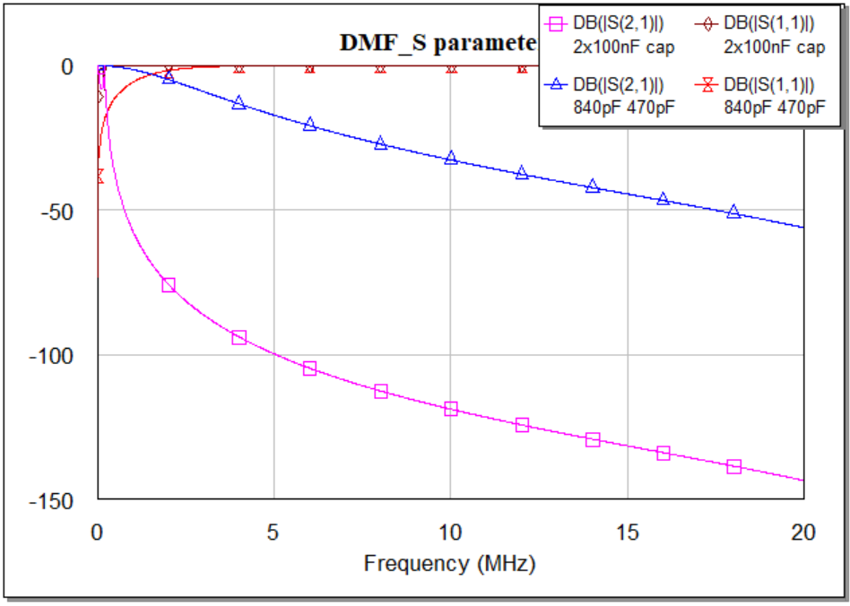

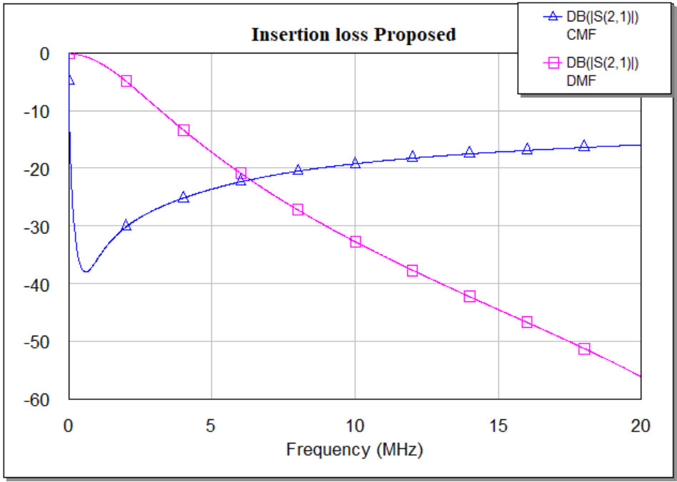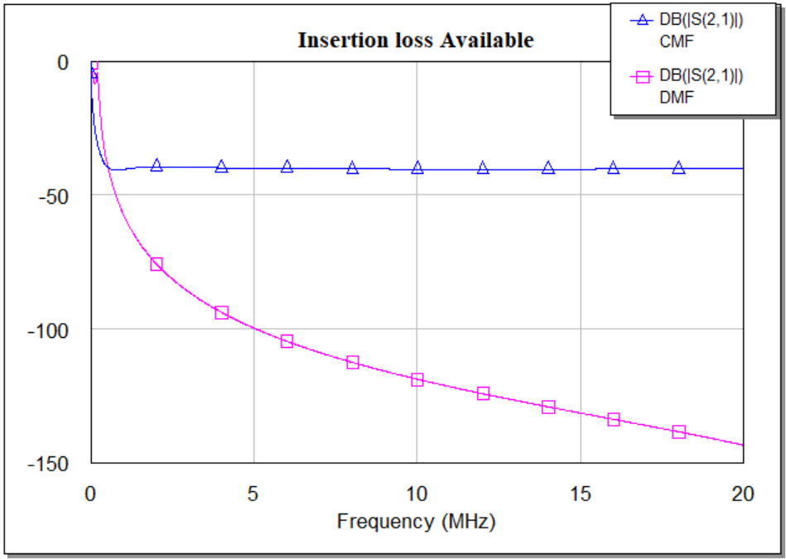

Figure 54: a) CMF s-parameters (s11, s21) for both 2x100pF cap and 2x2200pF cap

b) DMF s-parameters (s11, s21) for both 2x100nF cap and 840pF & 470pF cap

c) Comparison between CMF & DMF insertion loss (proprsed-2x100pF & 840,470pF)

d) Comparison between CMF & DMF insertion loss (available-2x2200pF & 2x100nF)

Discussion: For this specific case study as we have used a different model of choke having a different range of operating frequency. We have got different responses both for the common mode and differential mode filter. Considering the same standard filter design with the value of the capacitors, we have observed that in Figure 52, the insertion loss for the common mode filter is lower than the previous filter. On the other hand for the differential mode filter, the insertion loss is also lower for the capacitor set we have proposed.

### Nonlinear simulation

Nonlinear simulation can be divided into two domains. Here for the nonlinear simulation, we are using the same procedure. For time domain simulation, we have considered common mode filter and differential mode filter with common mode choke and different set of capacitors as we have used before. Again, for frequency domain test we have simulated harmonic voltage and harmonic power with respect to the noise frequency. In the following we have plotted only the AWR simulated graph.

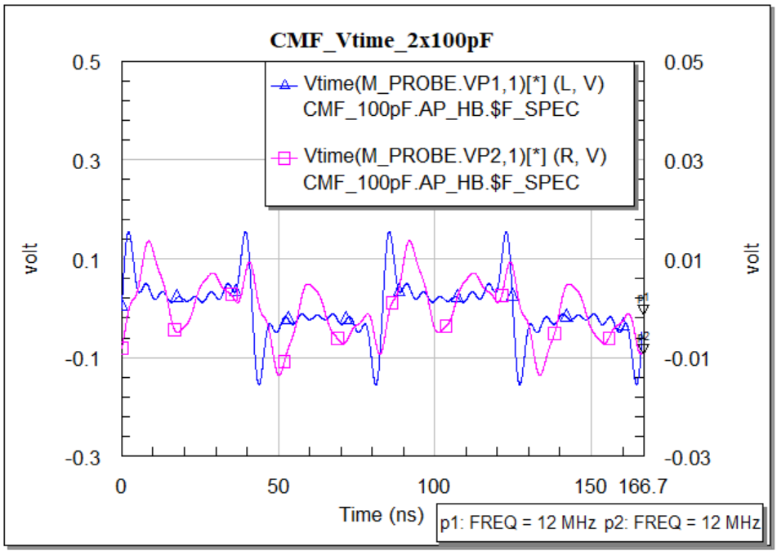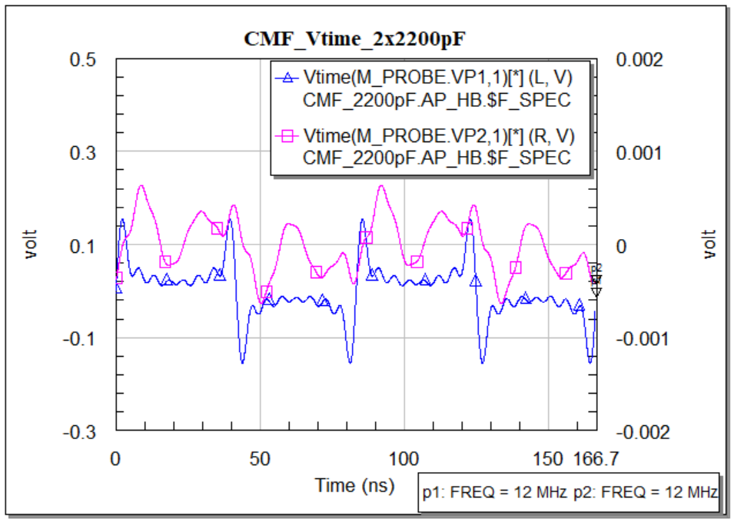

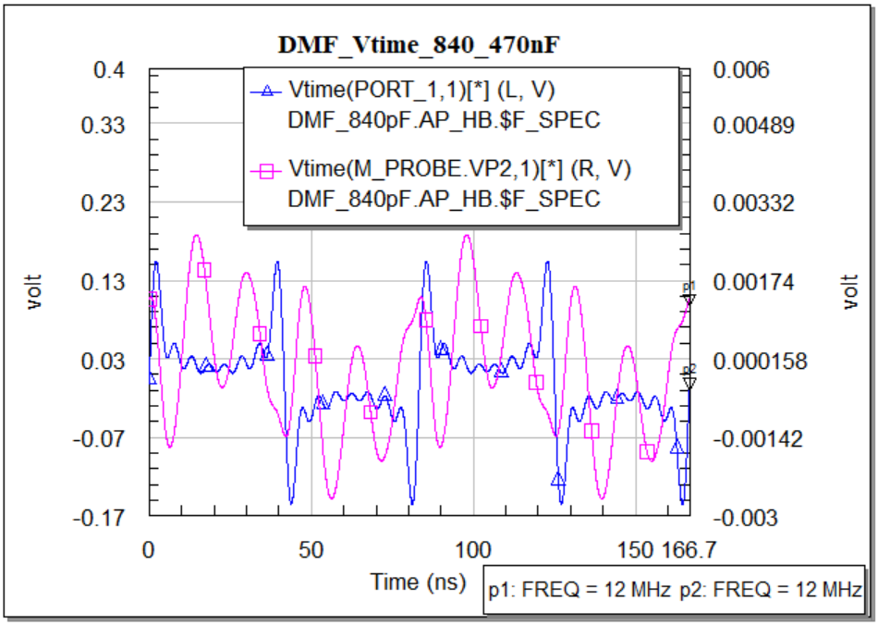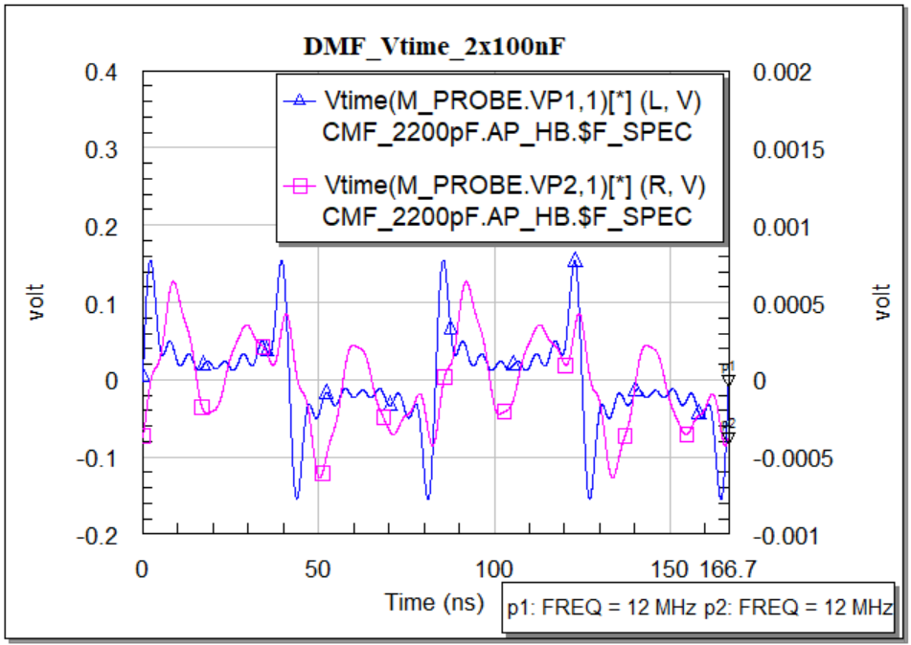

Figure 55: Time domain response of input and output CMF & DMF for 2 set of capacitor

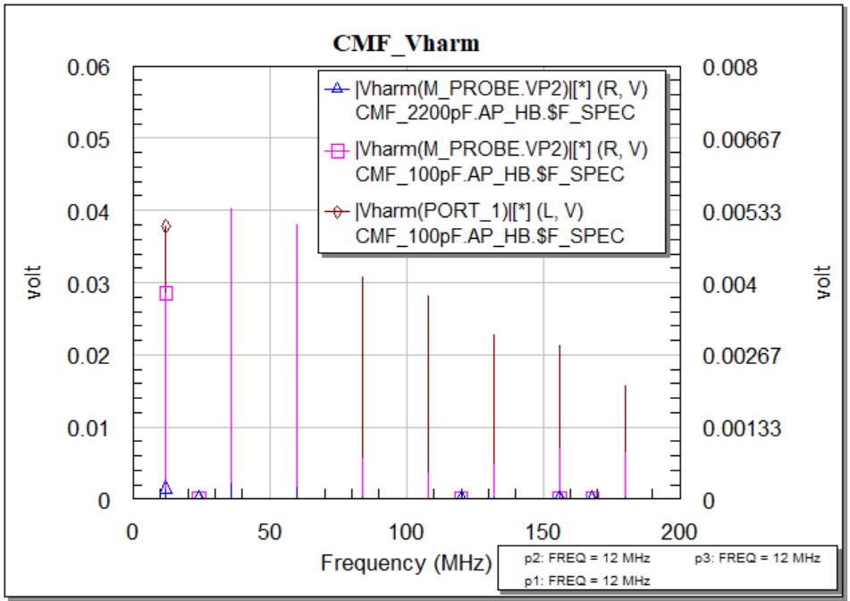

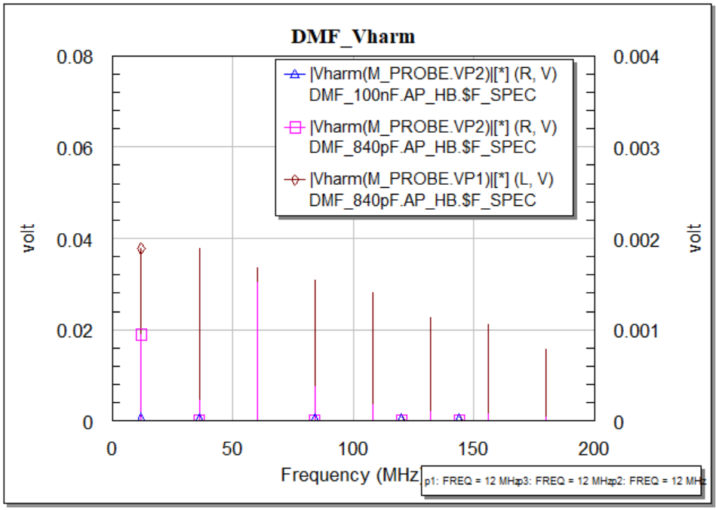

Figure 56: Frequency domain response of input and output harmonic voltage of CMF & DMF for 2 set of capacitors.

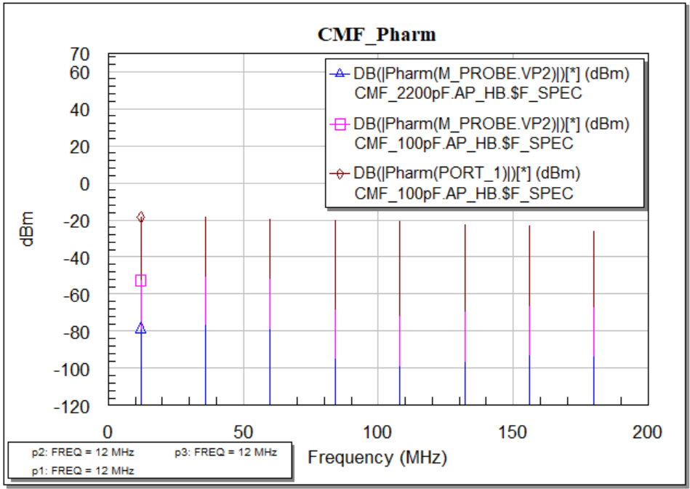

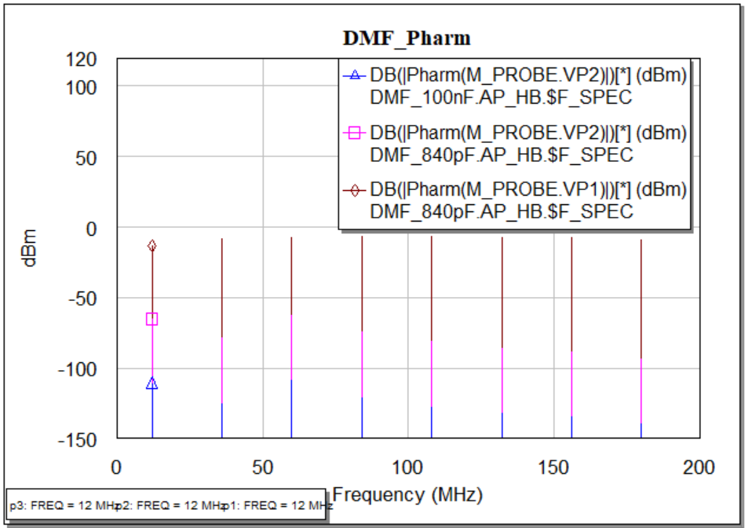

Figure 57: Frequency domain response of input and output harmonic power of CMF & DMF for 2 set of capacitors.

Discussion: We have measured the input, output results for the common mode filter and differential mode filter with the setup of 230V and 50Hz supply. In Figure 53, for the time-domain, the input response is different than the previous filter and this is because of the common mode choke. But the output response is not that satisfactory although, the magnitude is better than previous at some frequencies. In Figure 54, the frequency domain response is also better than the previous filter. It is seen that this power line common mode choke of the specific model we have used here is appropriate for filter designing in the low-frequency range.

## Case Study 2: Experimental Examples

### USB cables

Universal Serial Bus is a standard designed to connect to computers and other electronic devices. The latest version of this standard is USB 3.0, and the data transfer speed is very high, which is why this cable is currently very common.

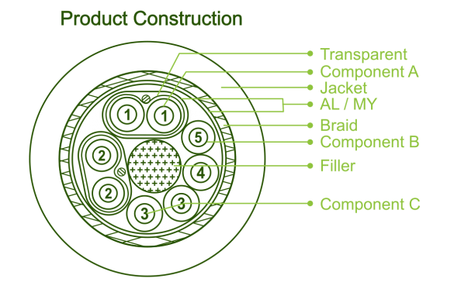 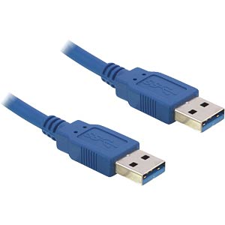

Figure 58: USB cable and its core layout [24].

All USB cables deliver 5 volts, only when it is connected to a high power device it can deliver a maximum of 12 volts. As we know that there are two pairs of cables inside a USB cable. One pair are used for data and another pair is used for power. The frequency range of the USB standard is between 480 MHz and 960 MHz. However, since USB 1.0 operates at a maximum frequency of 12 MHz and the voltage is 5 volts, we will approach the nonlinear measurement of USB 1.0.

#### Components selection

Since the power supply can produce both common mode and differential mode noise in a wide range of frequencies so to minimize the conducted emissions the EMI filter characteristics must be analyzed. For that reason, some of the experiments needs to execute to observe the voltage and power variation. As we have already measured the EMI filter output (both power and voltage) providing harmonic noise, we will measure and observe what the voltage and power variation happens if we connect another source having 5volt rms with 12 MHz frequency. In that case, we will use the same filter without changing its standard structure, common mode choke, and the X, Y capacitors. We are not going to change the values as well.

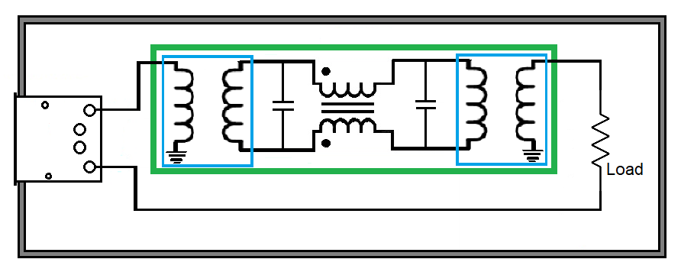

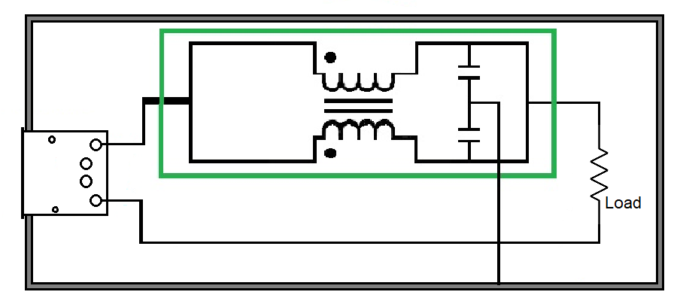

Figure 59: Circuit schematic of DM filter and CM filter with USB connection.

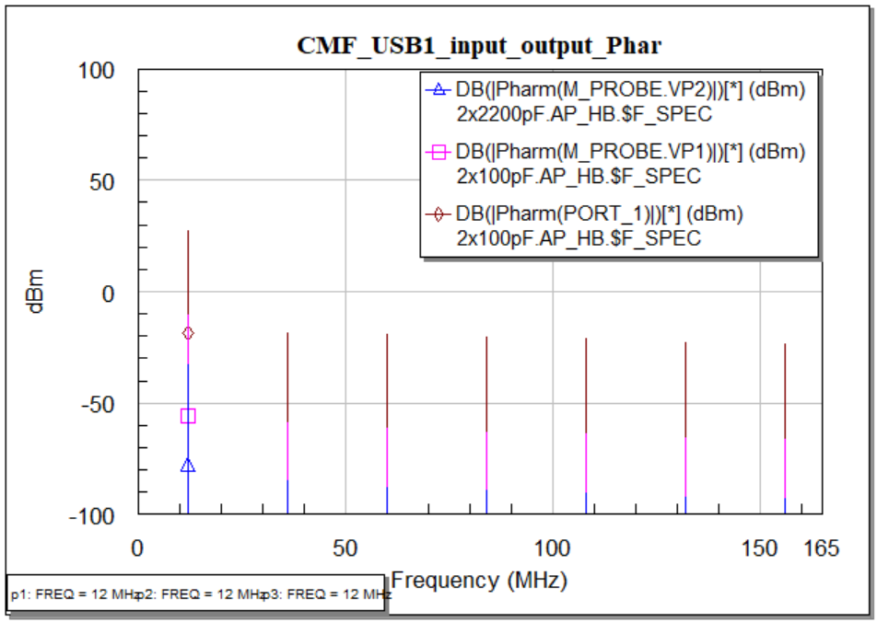

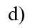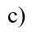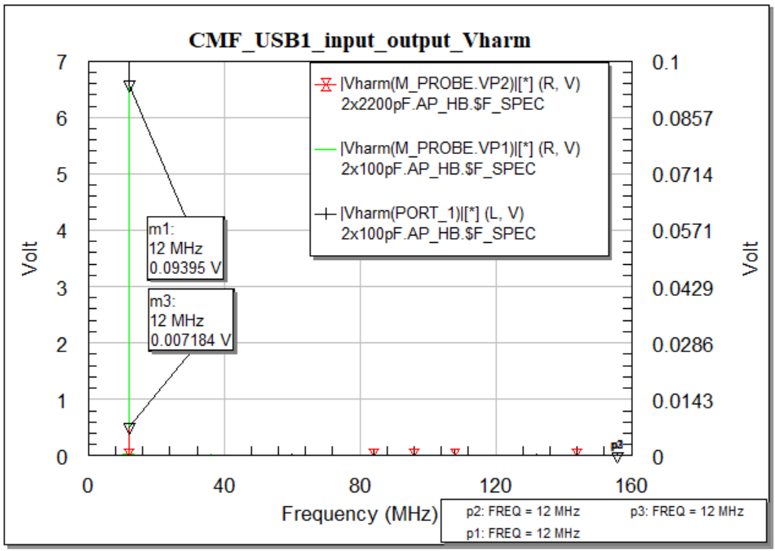

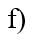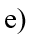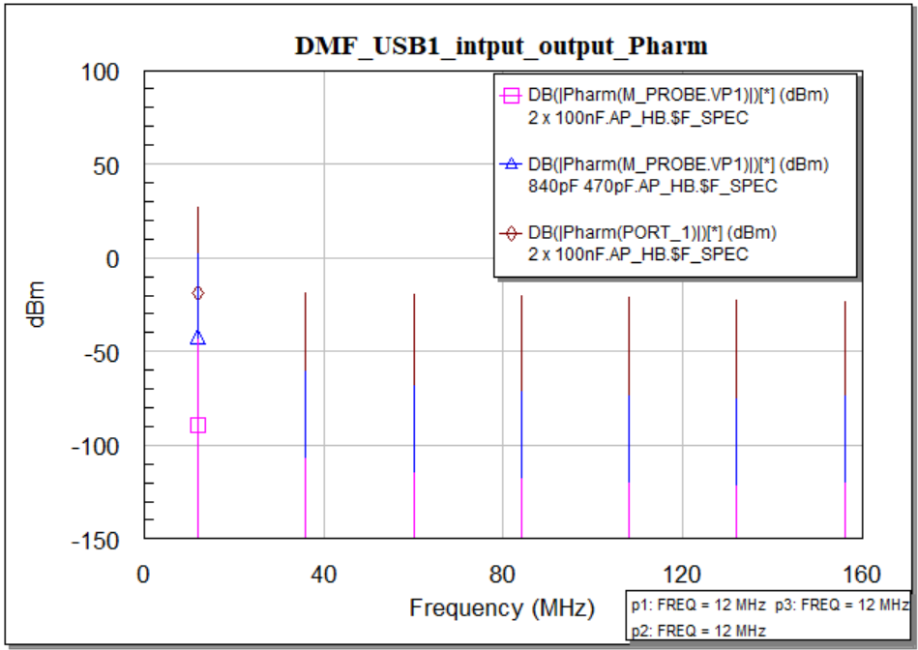

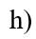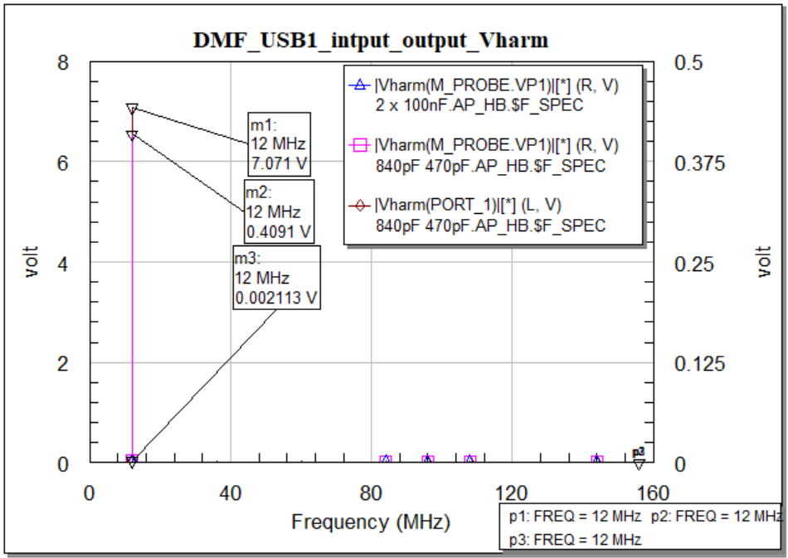

Figure 60: Common mode filter & Differential mode filter measurement for USB 1.0 cable towards the load a) CMF Power input and output in time domain (Pharm). b) CMF Input & Output harmonic power comparison. c) CMF voltage input and output in time domain (Vharm). d) CMF Input & Output harmonic voltage comparison. e) DMF Power input and output in time domain (Pharm). f) DMF Input & Output harmonic power comparison. g) DMF voltage input and output in time domain (Vharm). h) DMF Input & Output harmonic voltage comparison.

Discussion: Considering a USB 1.0 cable to test the input-output power of the filter is plotted in Figure 57. If we take a close look at the figure then we will see, at the operating frequency of the USB cable we get the higher response and the amount of power loss in the output is quite low. In this case study, we again can observe that the output response is better for the set of capacitors we have proposed. In the common mode filter, the input voltage at 12 MHz is 7.071V and on the other hand for the available model using two 2200pF capacitor the output voltage is 7.18mV. But as we have proposed a capacitor set 100pF, we have got the output voltage 94mV. Similarly input power

### Ethernet cables

Ethernet cables carry broadband signals to Internet-connected devices. There are a number of versions of this cable that are used for speed function only. The most commonly used Ethernet cables are unshielded twisted pairs. There are a total of four copper wires and each wire consists of two twisted wires. Each copper wire is covered with an insulating plastic layer. In an Ethernet, the electrical and optical properties are maintained by the physical layer and the data transmission layer. The line voltage is nearly 2.5 V. However, the processing bandwidth varies depending on the cable type. For cat5, the bandwidth is 100 MHz, while for cat6 Ethernet cables, it is 250 MHz. For cat6a, the bandwidth is much higher at 500 MHz. We will select one of the cables and test the input/output response including the noise signal.

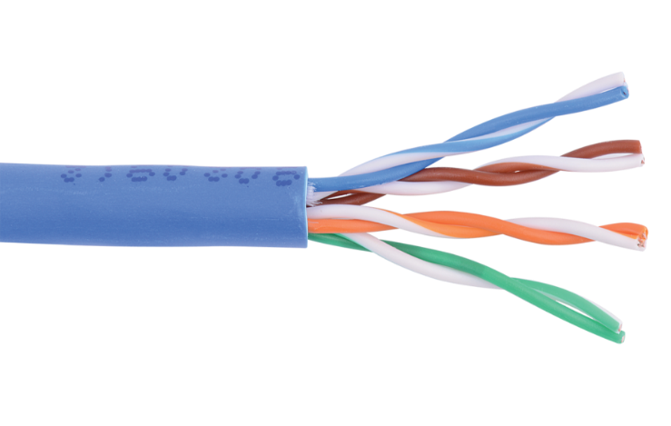

Figure 61: Ethernet cable and port having male and female port

#### Common mode measurement

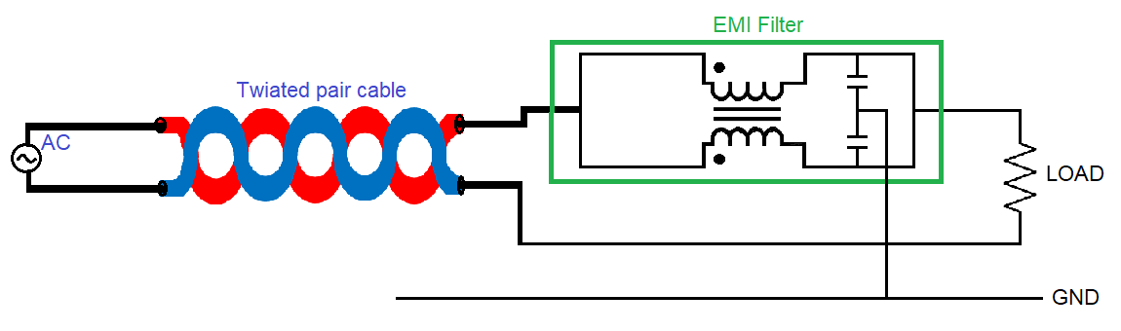

Figure 62: Circuit schematic with common mode filter.

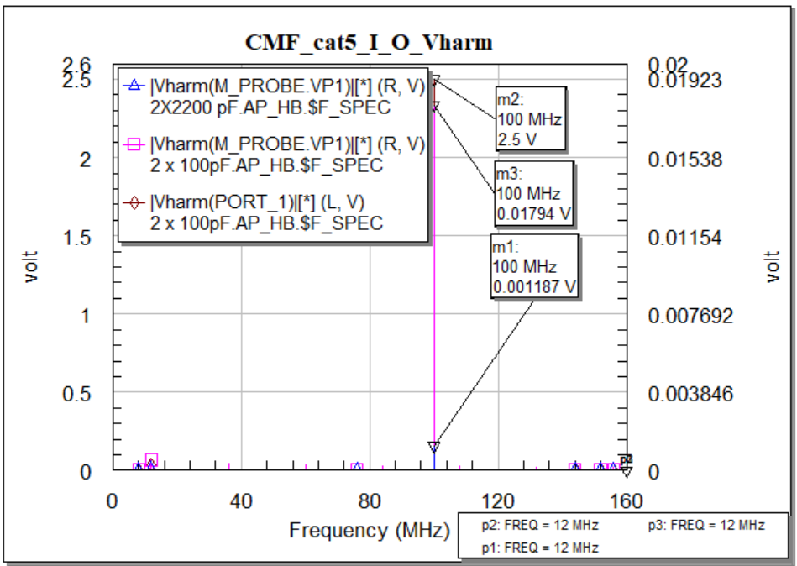

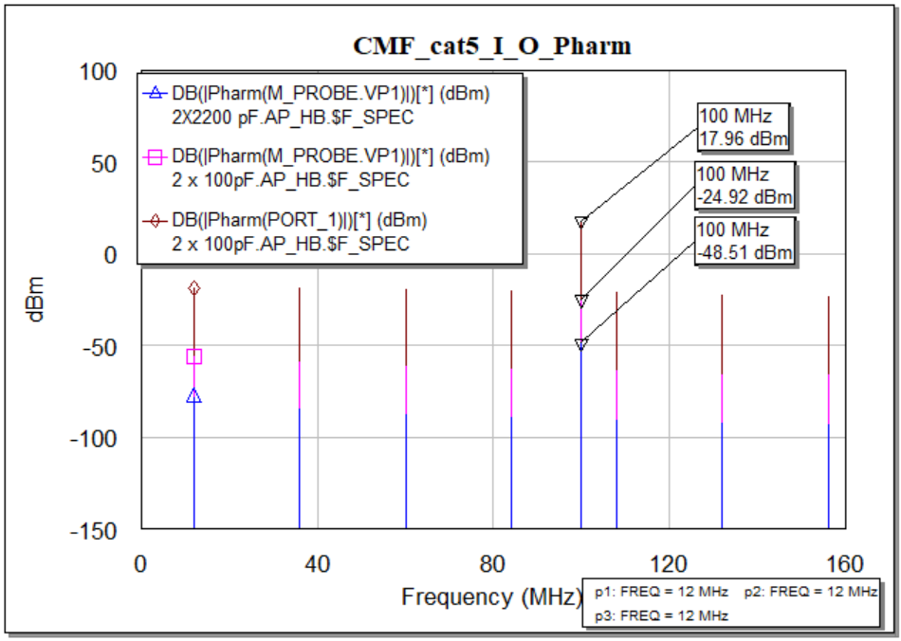

Figure 63: Common mode filter for cat5 Ethernet cable towards the load in frequency domain a) Voltage input AWR (Vharm) b) Voltage output Measured (Vharm) c) Power input AWR (Pharm) d) Power output Measured (Pharm)

#### Differential mode measurement

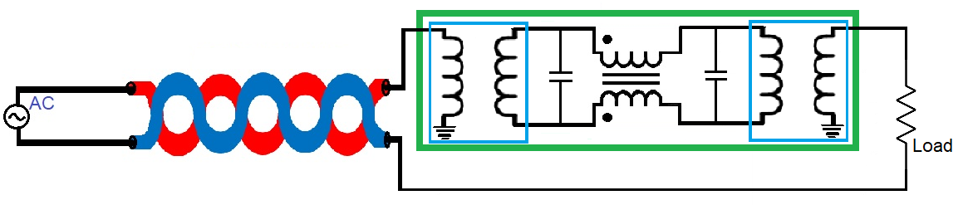

Figure 64: Circuit schematic with differential mode filter.

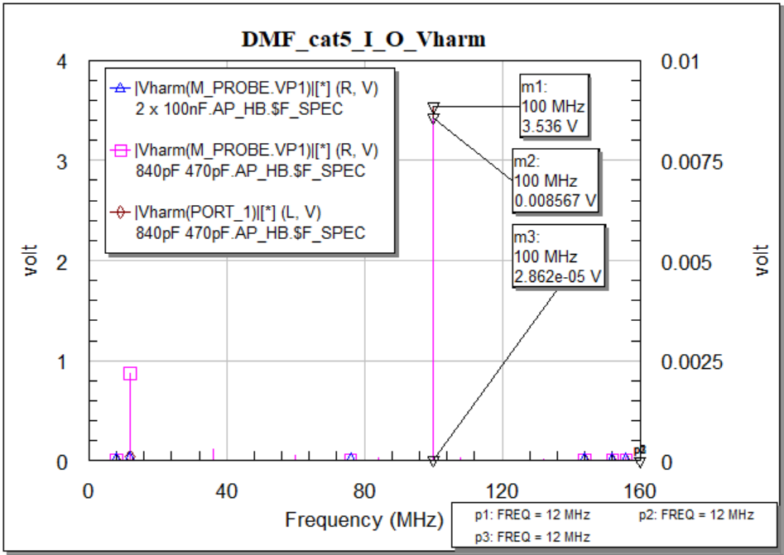

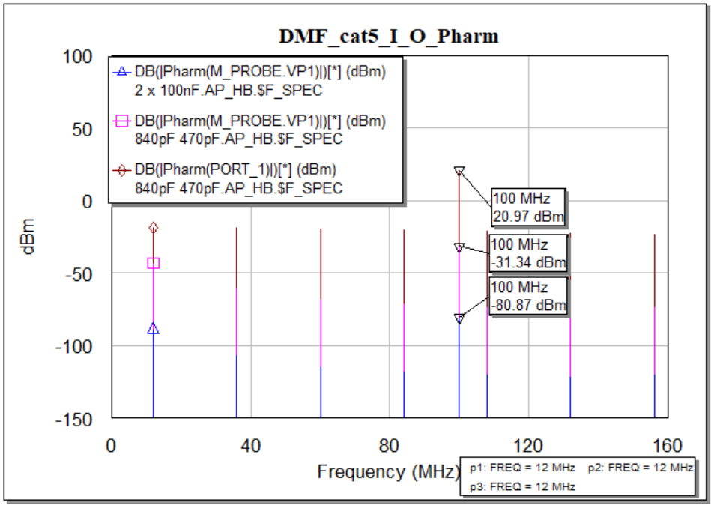

Figure 65: Differential mode filter for cat5 Ethernet cable towards the load in frequency domain a) Voltage input AWR (Vharm) b) Voltage output Measured (Vharm) c) Power input AWR (Pharm) d) Power output Measured (Pharm)

Discussion: For the second case study we have taken Ethernet cable (cat5) and in Figure 60 we have plotted some responses in the frequency domain only to observe the power variation and compare with the previous case study. We have seen as the operating frequency is set at 100MHz, the power response is higher. The main thing we have to observe is the output response which is not that better than the previous case. Although, again the output power is better for the capacitor we have proposed.

# Conclusion

In this paper, an EMI filter is designed based on the noise properties with low frequency. As we have selected the common mode choke having an operating frequency in the low range, the EMI filter has been considered as a low pass filter in the entire research and measurement as well. The main goal of this paper is to design an EMI filter, to simulate the filter with different valued components in the different frequency range, estimate the components value at which the attenuation is low, and measure the changes in frequency and time domain. All the simulations regarding linear and nonlinear characteristics of the common mode and differential mode filters are properly investigated and measured. Some comparisons were also performed to make sure the performances. The low-frequency profile of the common mode choke used in the EMI filter made it possible to study and implement. The influence of parasitic elements also took part to observe the tiny variations in response in different domains. This standard model of the EMI filter seems very useful for investigating the effects of parasitic couplings on their performances. Some calculations have been solved to match the resultant response of the components and the output of the filter. Some of the results were unexpected due to the noise characteristics, component properties, and transient properties. Starting from frequency test, many other techniques like coupling mechanism, grounding, filtering, careful PCB layout design, linear and nonlinear, multi-tone, have been applied to test and reduce the effect of EMI. All these techniques guided to design of the EMI filter. It is observed that the best way to reduce the conducted emissions caused, is to stop it at the point at which it enters and leaves. The next step of this thesis work is to measure the radiated emissions using these passive components that have been used to design the EMI filter.

# References

|  |  |
| --- | --- |
| [1] | W. contributors, “Electromagnetic compatibility,” Wikipedia, The Free Encyclopedia., [Online]. Available: https://en.wikipedia.org/w/index.php?title=Electromagnetic_compatibility&oldid=1043327448. [Accessed 9 September 2021 14:37 UTC]. |
| [2] | A. V. S. Bhd, “ME1400 EMI AND EMC,” [Online]. Available: https://ppt-online.org/152151. [Accessed 11 October 2021]. |
| [3] | W. contributors, “Electromagnetic interference,” Wikipedia, The Free Encyclopedia, 17 September 2021 18:02 UTC. [Online]. Available: https://en.wikipedia.org/w/index.php?title=Electromagnetic_interference&oldid=1044909084. [Accessed 3 October 2021]. |
| [4] | P. M. a. S. RAMAN, “Electromagnetic Interference (EMI) Measurement and and Reduction Techniques,” *PROGRESS AND CHALLENGES IN DEVELOPING ELECTROMAGNETIC INTERFERENCE MATERIALS,* vol. 49, p. 24, 2020. |
| [5] | K. Bellero, “EMI FILTER DESIGN,” 23 May 2018. [Online]. Available: https://impulse.schaffner.com/en/engineers-guide-to-designing-emi-filter. [Accessed 1 October 2021]. |
| [6] | E. Tran, “Environment/EMC/EMI,” Spring 1999. [Online]. Available: https://users.ece.cmu.edu/~koopman/des_s99/environment/. [Accessed 1 October 2021]. |
| [7] | W. D. V. M. Violette J.L.N., “Electromagnetic Compatibility Handbook. Springer, Dordrecht.,” in *Sources of Electromagnetic Interference*, Springer, Dordrecht, 1987, pp. 13-15. |
| [8] | G. BOCOCK, “Match modular EMI AC line filters to application’s DC supply needs,” 28 FEBRUARY 2020. [Online]. Available: https://www.edn.com/match-modular-emi-ac-line-filters-to-applications-dc-supply-needs/. [Accessed 5 October 2021]. |
| [9] | J. Preibisch, “Effectively protecting super-speed interfaces against EMI,” 24 JANUARY 2019. [Online]. Available: https://efficiencywins.nexperia.com/efficient-products/protecting-super-speed-interfaces-against-emi.html. [Accessed 7 October 2021]. |
| [10] | C. Kathalay, A practical approach to Electromagnetic compatibility, Pune, India: EMC Publications, Pune, 2014. |
| [11] | C. Paul, Introduction to Electromagnetic Compatibility, John Wiley & Sons,, 1992. |
| [12] | Tech Web, “Differential (Normal) Mode Noise and Common Mode Noise－Causes and Measures,” Tech web, 1997-2021. [Online]. Available: https://techweb.rohm.com/knowledge/emc/s-emc/01-s-emc/6899. [Accessed 13 October 2021]. |
| [13] | W. contributors, “Comb generator,” Wikipedia, The Free Encyclopedia., 26 July 2020 08:02 UTC. [Online]. Available: https://en.wikipedia.org/w/index.php?title=Comb_generator&oldid=969574770. [Accessed 15 October 2021]. |
| [14] | W. contributors, “Line Impedance Stabilization Network,” Wikipedia, The Free Encyclopedia., 9 October 9 October 2021 09:33 UTC. [Online]. Available: https://en.wikipedia.org/w/index.php?title=Line_Impedance_Stabilization_Network&oldid=1049011943. [Accessed 18 October 2021]. |
| [15] | W. contributors, “Two-port network,” Wikipedia, The Free Encyclopedia., 18 June 2021 00:50 UTC. [Online]. Available: https://en.wikipedia.org/w/index.php?title=Two-port_network&oldid=1029116605. [Accessed 19 October 2021]. |
| [16] | Cadence System Analysis, “How to Calculate a Transfer Function From S-Parameters,” 2021. [Online]. Available: https://resources.system-analysis.cadence.com/blog/2020-how-to-calculate-a-transfer-function-from-s-parameters. [Accessed 21 October 2021]. |
| [17] | tutorialspoint, “Network Theory - Two-Port Networks,” tutorialspoint, 2021. [Online]. Available: https://www.tutorialspoint.com/network_theory/network_theory_twoport_networks.htm. [Accessed 20 October 2021]. |
| [18] | EMI analyst software, “How to Calculate Filter Insertion Loss,” 2021. [Online]. Available: https://www.emisoftware.com/blogs/emc-analysis-calculate-filter-insertion-loss/. [Accessed 22 October 2021]. |
| [19] | giangrandi.ch, “Transmission line reflections, standing waves and return loss,” 2012. [Online]. Available: https://www.giangrandi.org/electronics/anttool/swr.shtml. [Accessed 14 October 2021]. |
| [20] | K. Z. M. G. B. D. Y. L. Ying Liu, “A theoretical and practical clarification on the calculation of reflection loss for microwave absorbing materials,” vol. 8, p. 38, 25 January 2018. |
| [21] | W. contributors, “Harmonic balance,” Wikipedia, The Free Encyclopedia., 1 October 2021 15:26 UTC. [Online]. Available: https://en.wikipedia.org/w/index.php?title=Harmonic_balance&oldid=1047588600. [Accessed 19 October 2021]. |
| [22] | Evaluation Engineering, “Simulating EMI Filters With Time-Domain Waveforms,” 1 December 1995. [Online]. Available: https://www.evaluationengineering.com/home/article/13000347/simulating-emi-filters-with-timedomain-waveforms. [Accessed 22 October 2021]. |
| [23] | B. A. M. E. Yusri Maslamani, “Multi-tone Test,” 2014. [Online]. Available: https://eng-old.najah.edu/graduation-projects/7128. [Accessed 5 October 2021]. |
| [24] | V. White, “S-Parameter Measurements Basics for High Speed Digital Engineers,” 25 October 2017. [Online]. Available: https://literature.cdn.keysight.com/litweb/pdf/5991-3736ENDI.pdf. [Accessed 17 October 2021]. |
| [25] | Textronix, “What is EMC/EMI Testing?,” tex.com, 2021. [Online]. Available: https://www.tek.com/what-is-emc-emi-testing. [Accessed 13 September 2021]. |
| [26] | M. BERMAN, “All about EMI filters,” 1 October 2008. [Online]. Available: https://www.electronicproducts.com/all-about-emi-filters/#. [Accessed 5 October 2021]. |
| [27] | Coilcraft, “Common Mode Filter Design Guide,” 2007. [Online]. Available: https://www.coilcraft.com/getmedia/9c231e30-04a2-4463-b679-c38b99b2669e/doc191_CMFiltDesign.pdf. [Accessed 7 October 2021]. |
| [28] | Biricha, “EMC Filter Design Part 8: EMC Common Mode Filter Design and Component Selection,” 4 March 2019. [Online]. Available: https://www.youtube.com/watch?v=UOCsqNtRL74. [Accessed 3 June 2021]. |
| [29] | J. P. G. P. a. a. G. K. P.V.Y. Jayasree, “EMI Filter Design for Reducing Common-Mode and Differential-Mode Noise in Conducted Interference,” *International Journal of Electronics and Communication Engineering. ,* vol. 5, p. 12, 2012. |
| [30] | M. Rine, “EMI Conducted and Radiated Emissions,” vac magnetics, March, 2016. |
| [31] | W. contributors, “Conducted emissions,” Wikipedia, The Free Encyclopedia., 17 May 2021. [Online]. Available: https://en.wikipedia.org/w/index.php?title=Conducted_emissions&oldid=1023580121. [Accessed 11 October 2021]. |
| [32] | R. Cheang, “Electrical Noise Suppression and Common Mode Choke,” Electronics360, 25 May 2018. [Online]. [Accessed 15 October 2021]. |
| [33] | Coilcraft, “A Guide to Understanding Common Mode Chokes,” 2021. [Online]. Available: https://www.coilcraft.com/en-us/edu/series/a-guide-to-understanding-common-mode-chokes/. [Accessed 16 October 2021]. |
| [34] | Mathworks, “S-Parameter,” The MathWorks, Inc., 2021. [Online]. Available: https://de.mathworks.com/discovery/s-parameter.html. [Accessed 20 October 2021]. |
| [35] | Cadence PCB Design and analysis, “Low Pass Filter Transfer Functions,” 2021. [Online]. Available: https://resources.pcb.cadence.com/blog/2019-low-pass-filter-transfer-functions. [Accessed 21 October 2021]. |
| [36] | W. contributors, “Propagation constant,” Wikipedia, The Free Encyclopedia., 11 October 2021 20:04 UTC. [Online]. Available: https://en.wikipedia.org/w/index.php?title=Propagation_constant&oldid=1049432032. [Accessed 23 October 2021]. |
| [37] | Europens Passive Components Institute, “An introduction to insertion loss and filter capacitor performance,” 27 November 2019. [Online]. Available: https://passive-components.eu/an-introduction-to-insertion-loss-and-filter-capacitor-performance/. [Accessed 22 October 2021]. |